ZOOMIE PROP
BY
JIM MEEKER

PROLOGUE
I thought it was time to write down a few humorous stories that occurred while I played USAFA Rugby from the fall of 1971 until the spring of 1974. I honestly do not remember much about the games-we won most of them and we suffered very few serious injuries. We were always undersized and better conditioned than our opponents. Aside from that, the games have become a blur over the past 40 years, and in reality, have lost their importance. After all this time, the only thing of importance to me is what happened off the pitch, the friends that were made, and a few memories of special events that occurred during the games. The following stories are as accurate as a senile 60 year old man, who sustained numerous blows to the head, can remember. The stories are true, and no names have been changed to protect the innocent. I have told some of these stories so many times over the years that the facts and names may not be exactly correct, but the stories are closer to fact than to fiction. I started dating my wife, Debbe, the summer before I ever set a foot on a Rugby Pitch and have kept in continuous contact with Tex Byrd all these years. I have corroborated all my stories and lies with them and all accounts bear some semblance of truth.
In doing research for this paper, I have made one startling discovery. The establishment, General officers all the way through AOC’s, treated the Rugby team like bastard step children! I suspected it at the time, but my pride of being a team member and of being a Cadet, did not allow me to see the truth. Looking back though all four of my Polaris year books, I discovered that there are only a few pictures and paragraphs covering the Rugby Club. I know all of us played with all our hearts and souls every time we stepped on to the pitch. Never did we ever think that we were not representing the USAF Academy!
I will be forever grateful to Tex Byrd for all the time and effort he put in to make the players lives meaningful. If any one of us were ever having trouble with our personal or military life, he was always there to help. He arranged the schedule, transportation and housing for all the activities described below. At great peril to his military career, he opened up his home to all of us and hosted numerous parties at his on -base house. Years later, I learned that Tex had developed a close personal relationship with the Commandant of Cadets, BG Hoyt S. Vandenberg. The General would invite Tex to his office for weekly informal chats about the team, suggesting new verses for our Rugby songs and deciding who would be the next Zulu Warrior. Tex became dependent upon the General’s friendly advice and his secret donations to the Rugby Club’s Beer Fund.
There were other coaches involved in the program such as Wing Commander Tony Mason of the RAF, and Major Al Osur, but they coached the A Side my first year and I did not have much contact with them. As a side note, Al played for the Denver Barbarians for a while. One of the goals that I had for myself was to “plant” him into the ground with a solid tackle, just once! On the field, Al had a very cocky manor about him and I wanted to get him for at least one good hit. I never did! He was extremely adept at avoiding direct contact, and I had to settle for just getting him down.

THIRD CLASS YEAR 1971-1972
I was first introduced to Rugby in the spring of my Doolie year. Intramural Rugby was a natural fit for me. All I remember about that experience was that all Rugby games were cancelled during Hell Week. We ran to the Rock instead. I guess they did not want any upperclassmen getting hurt by frustrated Squats.
In the Fall of 1971, Carl Stanberry (72) was a C1C in my new cadet squadron and he was a prop for the A Side that year. He was very influential in getting me to try out for the team. I was a frustrated football wanabee and needed to find a place to vent my frustrations with Academy life. I had met Tom Segulja, Warren Priddy, and Gary Read as walk-ons trying to make the Freshman Football Squad and I wrestled with Bobby Arnold as Doolies on the Wrestling team. We all showed up for Rugby practice that fall.
I had been taught from a very early age how to tackle and I was very good at it. “Square up with the runner, and plant the face mask in the runner’s chest” was a great method while wearing a helmet—a very poor technique in Rugby. In my first practice, the Coach (Tex or Tony) had us doing tackling practice. First up for me was Bobby Russell, an excellent athlete, but I had 30-40 pounds on him. I planted him in the ground! Unfortunately for me, I gave him a hip pointer with my forehead—I saw stars for two days! Note to self—do not lead with the face in Rugby. Another football technique that did not carry over well was the placing of your head in front of the runner when making an open field tackle. After a few times of bouncing my ears off of Warren Priddy’s knees, I was finally convinced to place my head behind the runner’s legs. Without these changes in fundamentals, I would not have survived.
Gary Read was the Tight Head Prop, I was the Loose Head Prop, and Tom Segulja was the 2nd row behind me. The three of us played every game together for 3 years. We were like one person on the field; we always knew each other’s abilities and covered each other’s weaknesses or mistakes. Tom and I always joked that he had kissed my ass for 3 years! Gary and I had a bond on the field that made us a force to be reckoned with. We were both short and stocky with average speed but exceptional endurance. We were a 2 man wrecking crew—we ran the open field together, never more than a shoulder width apart. We always tried to tackle simultaneously--Gary hit low and I hit high. In military terms, that would be called a force multiplier. All of other scrum positions had a continuous stream of very good players, depending on the year.
Since I was always the smallest prop on the field, I had to develop a few techniques to enable me to survive in this very hostile environment. I started lifting weights seriously in high school and keep it up at the Academy. After breaking my ankle wrestling as a Smack, I spent countless hours working out in the weight room, bench pressing and working on my neck strength. In 1970, no one else lifted weights seriously. I developed an unusual technique as a loose head prop, taking advantage of me strength and leverage, that gave me a tremendous advantage over every opponent I played against in the scrum. When the ball was thrown into the scrum, I would slam the crown of my head into the opposing prop’s sternum, arch my neck, and exert as much pressure as I could. This usually resulted in their prop arching his back to escape the pain being inflicted on him. With the opponent’s second row team mate pushing on his ass, the results were predictable. The prop’s feet would be lifted off the ground, and we would control the scrum. We very seldom faced a team that we did not dominate in scrum play. I passed this technique on to my successor, and I hope that it kept being passed on.
For line outs, I was the first one in the line. I could not jump, but I could contain my end of the line. I probably was not the “cleanest” guy on the field because I had developed a few illegal techniques to harass the opposition and to help equalize my height and weight disadvantage. One such technique was to undercut the other team’s primary jumper. When he went up for the ball, I would occasionally slide my squatty body under his legs. I would do this just to give them something else to think about besides catching the ball on the inbounds pass. In my first season on the A Side, this got me into a bit of trouble with an important player. We were playing the Denver Barbarians at the Academy and they had a tall 2nd Row named Russell. He was also a big cheese in the Rugby Union and was a regular referee for our games. During a line out on the east side of the field, Russell jumped high, arms up-stretched for the inbounds pass, as I slid under his legs. After catching and releasing the ball to his scrum half, he crashed to the ground headfirst at my feet. The next thing I knew, he was in a sitting position, head just above my waist, with a vice grip on my balls! (Russell did not know that I was a decent boxer with a very good left hook). After appraising the situation, I took the proper action—I delivered a vicious left uppercut to the underside of his jaw, lifting him 6 inches off the ground. The play stopped on the west side of the field a few seconds later after the ball went out of bounds. I looked back across the field and saw Russell lying motionless where I had left him. After the game, the two of us had a short, terse discussion about how dirty I was and about how stupid he was!

ROYAL ROADS MILITARY COLLEGE
Royal Roads was a military college for the Canadian Armed Forces until 1995, when it was converted into Royal Roads University. The site had been a private estate, complete with a castle and formal gardens, purchased by the government in order to secure the safety of the British Royal family at the start of WWII (the Royal Family stayed in the U.K.). In the Fall of 1971, Tex Byrd and Bruce Alcorn took the B Side aboard a C-141 from Pete Field and flew direct to Victoria, BC.
The hospitality shown to us made an impact on our entire team. As our bus pulled through the gates of Royal Roads, we were met by their Military Band and School Dignitaries. We had all seen how we welcomed visiting teams to USAFA, and we were quite impressed by the difference in our reception. We were all housed in the Cadet Dorms with the Canadian Cadets, and dined at their facilities. I believe that we lost the game by one try, but like I said, scores and wins/losses have blurred over time. However, we did reward our Coaches for the loss by “encouraging them” to swim naked in a nearby pond. They reported to all the “innocent bystanders” that the ice cold water was quite refreshing!
After the game on Saturday afternoon, they had a large party/dance in our honor. In another unbelievable show of hospitality, they had arranged dates for every member of the team (Tex was on his own!). Keeping with Cadet tradition, each Rugger threw a Dollar into the “Pig Pot”, the consolation prize for the player who was stuck with the ugliest date. I do not remember the lucky winner’s name, but I can still see his forlorn face. Unfortunately for me, I was the Runner-up!
The Royal Roads trip was special for me. My big brother Dan and my older sister Pat both taught school in Washington State. They met in Seattle, and drove up to Victoria for the game. It was the first opportunity for them to see me as a USAFA Rugby player. It was funny to ask both of them 40 years later what they remembered about the game. Dan’s only recollection was that Tex offered him a snort of booze from his private flask! (Tex does not remember doing this). Pat only remembers me dropping my shorts at the end of the game! ZULU WARRIOR strikes again!
The send-off we received on departure mirrored our arrival - Bands and Dignitaries. They knew how to make guests feel special and respected. I never have forgotten their hospitality.

The Mask
During that winter, I boxed on our intramural team. I did pretty well and ended up losing in the semi-finals of the Wing Open Tournament. I was a slow learner and kept leading with my face! I ended up breaking my nose several times and became a “bleeder”. I lost in the semi finals because I was bleeding. When Rugby began, my nose still had not healed. The hockey team trainer made me a fiberglass mask to protect it. It was painted black, making me look like “Zorro”. In the end, I figured out how to use it like a football face mask, and my nose did not heal very fast. I quit wearing it when I ended up in the hospital ER after a game with double vision, caused by looking through the mask.

NEW MEXICO
The only other significant road trip my 3rd Class year for the B Side was to New Mexico. We piled into a USAFA bus for the long road trip to Albuquerque to play a local club. It was impressive to see a 58 year old fullback still playing the game. The only event of significance happened after the party. The enlisted bus driver had been quite taken in by our partying and decided to join in with all the festivities. Late that night, a few of us went “cruising for women” in the Academy bus with a rather tipsy driver. I do not think that would have gone over well with the Commandant. On the way back, we stopped to play a team from Santa Fe.

SECOND CLASS YEAR 1972-1973
The A Side Rugby team for the 1972-1973 school year was without a doubt, the best team that I ever played on and I would argue, one of the top 5 teams USAFA ever put on the pitch. We were small, fast, and most importantly, played as a single unit. The team was a made up almost entirely of ‘73 and ‘74 team members. The Class of ’73 had Denny Merideth and Bill Diffley at wing forward, team captain Tim Hayes in the back line, and Tommy Schuessler at scrum half. Terry Geers held the scrum together as the #8. I cannot remember the hooker’s name (does anybody remember a hooker’s name?), but he was also from ‘73. From the Class of ‘74, we had Tom Segulja and Bill Murphy at 2nd Row, Gary Read and me at Props, and Warren Priddy, Jimmy Grandcolas, Ron Walker, and Bobby Russell on the Wing. Bobby Arnold was the Fullback, and Bruce “Bup” Barry was our place kicker/back. I know there was a cadre of other talented classmates who also played at various times, but to the best of recollection, the above named players played the majority of minutes that year.

ASPEN RUGGER FEST 1972
In the autumn of ’72, we traveled to the mountains of Central Colorado to play in the Aspen Ruggerfest. We thought that we would do well, but had no expectations of winning this prestigious national tournament. Most of our teammates were intimidated by the pedigree of the teams represented there. The Kansas City Blues and the Bay Area Touring Side (BATS) were legendary at that time. All of the teams were much older, bigger, faster, and more experienced than we were. I honestly do not remember a single moment from any of the numerous games played over the 2 or 3 days. I do not know what the experience was like for my team mates or coaches, but I do remember what the experience was like for me. The words “hell”, “beat up”, and “total exhaustion” come to mind. You have to remember I weighed less than 190 pounds and for 3 days I was in there fighting, biting, scratching, kicking, and yes, arching my neck against the largest, most hostile individuals in the Rugby world. My body was almost destroyed that weekend by countless battles in scrums and line outs and by open field tackles against collegiate caliber running backs. As I am writing this, I am holding my most prized possession—a 40 year old tarnished silver goblet with the inscription
ASPEN
1ST PLACE
1972
Over the years this modest cup has proudly sat in a prominent place on my fireplace mantle. I have always resisted the urge to polish it and it serves to remind me of what can be accomplished with hard work, perseverance, and teamwork.
After wins against the Blues and others, and defeating the BATS in the final, we went back to the North Star Motel to get cleaned up and relax. It was only natural for all of us to jump, fully dressed, into the Motel’s swimming pool. It was a great way to get rid of all the “Mud, Blood, and Beer” that we had accumulated. We left a hell of a mess in the pool and possibly a few broken pieces of lawn furniture around the pool deck. Tex had to use all of his “smoozing” powers to cover up the team’s tracks after that party. I’m sure that his secret pal, General Vandenberg, worked closely with him in this cover up! I was so battered and bruised from the numerous games that I had to ride home lying down in the back of Denny Merideth’s Datsun 240Z. My wife reminded me that we had a “full house” in that tiny car. Denny was driving, his girlfriend and her small child were in the passenger seat, and Debbe was curled up next to me in the back. Who said that the 240Z was a 2 seater!
To show their gratitude for us winning this prestigious event, the Academy officials refused my request to be excused from the PFT the following Monday afternoon (some pull Tex had!). Suffering from extreme exhaustion, I barely did the minimum in each of the 5 events and I did not think that I could finish the 600 yard run. This was the only time that I failed to score above 400 in the PFT.

RAF CRANWELL
During spring break of 1973, the A Side boarded a C-130A at Peterson field for a 23 hour flight to RAF Cranwell, stopping in Goose Bay, Labrador for rest, and Keflavik, Iceland for fuel. For those of you unfamiliar with this particular mode of transportation, it was brutal! We were sweating above the waist, while our feet were freezing. The nylon strap troop seats added to that luxurious feeling. However, we barely noticed these inconveniences over the roar and vibration of the three bladed props. We brought over with us a USAFA contingency of “Dancing Bears”, non-Rugby Cadets and Officers to ensure our proper behavior. More about the “Bears” later.
In Goose Bay, all of the Cadets were housed in the BOQ. Tex and the other officers were put up at the VIP Hunting Lodge, completely stocked with all the “necessities of life”. An interesting side note—the Michigan Air Guard was transporting 47 cases of Coors Beer that they purchased in Colorado Springs. At that time, Coors could not be purchase east of the Mississippi River. The Beer made the complete round trip unscathed.
The British were perfect hosts. On the night after the game (we won), they hosted a Dining In for all their guests. The Dining In started with all the Pomp and Circumstance one would expect for an International event being hosted by a 1 Star General. We were called into the Mess by a chorus of Buglers dressed in traditional garb, including tights, playing long silver bugles from the balcony. It sent shivers down our spines. After all the colors were presented and toasts were made, one could hear a pin drop in the Great Hall. Suddenly, out of the crowd of reverent Ruggers, flew a dinner roll aimed for the guests at the Head Table. (The dinner roll was later triangulated back to the vicinity of where Tex was seated. To this day, he denies throwing the first roll, but I am not convinced.). The General, in an act of self defense, returned fire. The Dinner Roll Fight was on! After this event and countless trips to the Grog Bowl, all sense of decorum left the room and a great time was “had by all”, that is “all” except for the “Dancing Bears”.
After dinner, the Mess was adjourned to the Bar. Before leaving the Mess, we were instructed to follow the old Cranwell tradition of tying our cloth napkins together under the tables to form one continuous long loop. This was their way of harassing those responsible for cleaning up. At the Bar, great quantities of alcohol were consumed and worn, and it became difficult to distinguish the Limeys from the Yanks. We had exchanged every part of our Mess Dress uniform for theirs. To this day, I still prize the British bow tie and blue cummerbund that I exchanged that evening. Some Cadets even swapped pants, shirts and jackets. It was later learned that a record was set that evening for the most beer consumed at that Officer’s Club during one event- a full 7 kegs! I did not drink beer back then, but I did have 4 double rum and Cokes!
All of this was told to set up what happened next - one of the funniest sequences of events that I have ever witnessed. After everyone in the bar was drunk on his ass and out of uniform, in walked a stone cold sober “Dancing Bear” who had come along to chaperone us. He walked up to Tim Hayes and tried to get Tim to stand in a brace while chastising him for being out of uniform. Tim stood in a sloppy brace- chin in, chest out- and tried to look him in the eye (or at least, the best that he could through his own bloodshot ones). With his left hand held perpendicular to his body so as not to spill his beer, Tim reached over with his right hand, snatched the AOC’s clip-on bow tie and dunked it in his own beer. While still at attention, and without saying a word, Tim then reattached the AOC’s bow tie, straightened it out, then did an about face and departed the immediate area. Come to think of it, Tim may have respectfully suggested to the Captain something about “loosing up” and “have a good time”.
Needless to say the “Bear” was enraged. He marched over to Major Tex Byrd and demanded satisfaction. He rambled on and on about Form 10’s, marching tours, etc. for the disrespect that this Cadet had displayed towards a superior officer. Tex, who was in the same condition as the rest of us, looked the Captain in the eye, reached up and snatched the soggy bow tie from the his neck, dunked it in his own beer, placed the beer-laden tie back on the Captains neck, and walked away.
Still not properly assessing the situation, the “Bear” walked up to Colonel Mandy Baird, our team “Academic Advisor”. In truth, he was the Commander of the Cadet Dental Facility. He just liked to have fun and did not spend a lot of time worrying about alcohol regulations. I’m sure he too was very good friend of General Vandenberg. The Captain “Bear” explained the best he could about the injustices he had just endured at the drunken hands of our Team Captain and those of our Coach. In a manner fitting Frank Burns from MASH, he demanded satisfaction. Col Baird looked the “Bear” in the eyes, reached up and grabbed his drenched tie, dunked it in his own beer, and placed it back on the disheartened Captain’s neck. Standing at attention with a beer-stained dress shirt and beer- soaked tie, the “Dancing Bear” Captain received a tongue lashing befitting of the circumstances. He was told: “If you cannot enjoy yourself, get the hell out of here!” Tim never heard anything more about the incident.
Sometime later in the evening, we were challenged to a Jousting Tournament in the Great Hall. The ‘Steed’ was a drunk, riding a tricycle. The ‘Lance’ was a mop. The ‘Knights’ would mount their ‘Steed’ by sitting on the shoulders of the drunk. When the signal was given, the thundering ‘Steeds’ would charge each other, while the ‘Knights’ lowered their ‘Lances’ for the kill! What could possibly go wrong with this scenario? After a few passes at each other, common sense prevailed. The Joust downgraded to a bunch of drunks riding tricycles up and down the Great Hall.
At the end of the evening, Bill Diffley and I were staggering down the main hall and stopped under the Great Rotunda. This was a place of reverence for the Brits, a Hall of Honor for all those who had gone before us. While admiring the pictures and beautiful carpet in the rotunda, a “target of opportunity” presented itself. A kindly gentleman with one star on his shoulders, walked by, and bid us “good evening”. Without hesitation, I yelled out “scum down”, ran over to him, gently placed him on the carpet, and held him in a wresting hold until Bill counted to three, signifying that the General was pinned. The General was a good sport about being bent in half and tied up like a pretzel. After I released him, the General made his final escape, riding down the hallway on his motor scooter. Luckily, I never heard any complaints upon reaching the Academy.
The next day we went to London. We awoke early to take advantage of buses provided to us by the RAF for a day of site-seeing. None of us had ever been there before and truly it should have been a day to remember. Unfortunately, we all had a terrible hangover. After a full day of wandering around the streets of London, riding the Underground and double-decker buses, it truly was a miracle that we all made it back to Cranwell. One of my souvenirs from that trip was a photo taken by a street photographer. Warren, Gary, and I were walking the streets when the man approached us to take our picture. For a minimal cost of 10 Pounds each (about $25), he would send us the pictures. We were gullible enough to pay him the money. About a year later, the picture arrived in my mail box.

Fort Meade and Annapolis
Later that spring, we traveled to the US Naval Academy in Annapolis, MD. Tex had met the coach of the West Point Rugby team, a British Artillery Officer. He was friends with the Navy coach, a Marine Major. The three of them planned the first Tri-Academy Rugby Tournament to be hosted by the USNA.
As always, Tex arranged for our transportation and lodging. We flew on Tex’s favorite form of transportation, a C-130, but I do not remember it being as bad as the Cranwell trip. For some reason, housing was not available at Annapolis, so he secured us housing at Fort Meade. It was a condemned WWII open bay barracks. Fortunately, we were not there very much. Try to imagine getting a good night’s sleep with a bunch of drunken Ruggers practicing Rugby songs. I remember specifically rehearsing late into the night the “Alphabet Song”, Bobby Arnold’s new favorite song that we had just learned from the Brits. “A is for Asshole all covered with hair,……X,Y and Z you can shove up your arse”. I can still recite that song flawlessly!
We played two games on that Saturday, Army in the morning and Navy in the afternoon. We beat Army handily, but lost to Navy later in the day. Tex shared with me a play that happened against Navy, one of the best plays he has ever seen. Ron Walker was the end Winger and had the ball, running down the sidelines near their 25 yard line. As he was being tackled by multiple Navy defenders on the sideline, he made a “blind”, behind the back pass, to one of our backs, who was trailing the play to Ron’s inside. That back ran untouched for the try, which put us ahead at the time. Navy later took the lead for good. We had a chance to win or tie, I cannot remember which, but “Bup” Berry missed a last second mid-ranged kick. I know he felt bad, but his foot had carried us to victory numerous times and no one faulted him.
Later that night, a group of us were in the Ft. Meade Officers Club. In the Ball Room, the Army was having a formal function. The Officers were wearing their Dress Blue uniforms, the ones that look like Calvary Soldiers from the Old West, and all the ladies had their hair up and were wearing beautiful gowns. We stood in the entry door for several minutes before we decided to leave. In the doorway there was a knee high, sand-filled ashtray. As we left, an unnamed Rugger deliberately kicked over the ashtray, causing a loud noise and sending sand flying into the Ballroom. The Army Officers and their Ladies stood watching in disbelief as we made our getaway. I was appalled. I could not believe that anyone, especially an Academy Cadet and teammate, would do something so rude and crude. It was the only time that I was ashamed to be associated with the team. I’m sure Tex and General Vandenberg had a good laugh about this event over an ice cold beer!

FIRST CLASS YEAR 1973-1974
We lost only five starters from the Class of ’73 and we were hoping to have as good a year on the Pitch that year as we did the year before. Several of my classmates became regulars that year, including Tommy Weiss, Louie Appelhans, and Chuck “Fitz” Fitzpatrick. Mike Maquet , Vic Calazzo and Nate Rosenberg also played at times. The ’75 and ’76 replacements were all as good as athletes as the ones they replaced. From the Class of ’75, “Shep” Sheppard played #8 and Mike Delaney, R.L. Benbow, and Dan played in the back line. Although Dan’s last name escapes me, I think Dan won the “Pig Pot” on the Royal Roads trip. I believe Sal Reza (’76) was the Hooker, but like I said before, who can remember a hookers name? He was joined by his classmates Jim E. Carter at Scrum Half and Mark Fauver played somewhere behind me. While we had excellent athletes that year, we were never able to play with the consistency and achieve the success of the previous year.
It’s time to tell a quick story about Chuck Fitzpatrick. Chuck started 9 or 10 games as a Junior defensive back for the Falcons, and Ben Martin cut him in Spring Training. I’m sure there was more to the story, but he was a welcome addition to the team that Fall. Fitz was a walking optical illusion. He was tall and muscular, with broad shoulders and a narrow waist. Only one problem- He had a tiny head! Chuck wore a size six hat that made the rest of his body look bigger. He literally was a human Doberman Pinscher, and fortunately for us, played like one. I still remember his first game that Fall. He had not yet made the mental transition from Football to Rugby. Early in the game, the opposition scum won the push and the ball came out down their wing. Chuck broke from his Wing Forward position and proceeded to destroy every opponent who touched the ball, from the Scrum Half to the end Winger. He made every tackle-solo! When he got up he was exhausted and I could tell he was waiting for his name to be called on the PA. “In on the tackle, #7, Chuck Fitzpatrick!” The announcement never came and he sat there looking bewildered when the noticed the ball was already 25 yards away. At half time, I had a discussion with him about “pacing yourself” in Rugby, a concept that is not acceptable in football but is essential in this game.

VIRGINIA MILITARY INSTITUTE
In the fall of 1973, we traveled to VMI. Tex had arranged our travel on a VC-120, complete with a Steward and catered meals. The plane belonged to a 3 Star General from a Numbered AF at Kirkland AFB. Numerous cases of beer were rumored to have disappeared from the galley on the flight east. VMI is a beautiful campus located in Lexington, VA, and has a long line of military and civilian leaders as their graduates. The grounds had an arched walkway which people walked under and had several statues of famous alumni scattered nearby. We were housed in what looked like an old barracks, away from the VMI Corps.
Upon our late night arrival to VMI, we were greeted by the entire Keydet Corps. For a moment, I thought that this was going to be another special greeting like the one we received at Royal Roads. That was not the case. We arrived to see the most frightening and somber ceremony held at any institution. The Corps was “Drumming Out” a cadet for an honor violation. We had entered the ground floor opening of their large, four story, quadrangle shaped dormitory. The Keydets were all standing at attention on the balconies outside their rooms looking down into the center of the grounds. While the disgraced cadet stood at attention in front of us, his uniform was stripped of its rank, his belongings were thrown off the balcony, and in unison, his former colleagues did an about-face, turning their backs to him. A lone drummer began to play the death march as the former cadet marched out. For the offender, that was it. His name was erased from the rolls of VMI and no VMI graduate would ever have contact again with him for life! Wow! Our Honor Code violators just disappeared, without most people knowing what had occurred. .
On Friday afternoon, the Keydets were milling around before a parade, dressed in their Parade uniforms; Grey jackets, tall hats (Shakos), and starched white pants. One of our cadets (who shall remain nameless again) decided it would be funny if he pissed on one of those VMI cadet’s starched white pants. He walked up to him, and while talking to him, pissed all over the poor guy’s leg. The pants had so much starch that the piss just ran down the side of his shoe and pooled harmlessly on the ground. Crude, but funny! I still do not know what goes through someone’s mind to think of doing this.
We played the game on a Saturday morning and won. After the game, we got into our Blues and marched on with the Corps for their home game with Navy. That night VMI had a dance for the Corps and we were invited. They bussed in girls from a nearby girl’s college, not just for us, but for all cadets without dates. Several teammates made connections with the girls from Southern Seminary, and made arrangements to meet them at their school on Sunday night. The evening went well without anyone getting into serious trouble.
For some odd reason, one of our Ruggers was fascinated by “marking his territory” everywhere that he could. The white pants were not enough. That evening he pissed from the top of the walkway while couples were walking under it and he followed that by climbing up onto the 10 foot tall bronze statue of “Stone Wall” Jackson and claimed him for USAFA. No complaints were filed.
Sunday evening, 8 or 10 of us piled into two rented cars and headed over to Southern Seminary to see if we could meet some of the girls from the night before. Despite Mike Maquet’s pleading for us not to go, we went, leaving him behind. He was afraid that we would get into trouble and that we might not return early enough to catch the plane back to the Academy Monday morning. I had not met any of the girls myself, but it seemed like a good idea to go at the time.
We parked our cars in a parking lot near the school’s equestrian track, spit into several small groups, and walked towards the dormitories. As Gary Read and I walked by a ground floor dormitory window, a female voice called out to us. We stopped and chatted for several minutes and then a few more girls joined the conversation from their windows. We learned from them that it was after their curfew and that men were not allowed in the dorms. They had House Mothers who enforced these regulations. Several minutes later we heard a warning horn go off inside their dorm and, almost immediately, two Campus Police cars pulled up, one on each side of the narrow parking lot. Gary and I were trapped like rats and all we had been doing was talking to the girls without setting foot inside of the dorm.
Upon seeing the campus police, we followed our natural instinct-hide! Gary and I dove under two near- by cars to escape detection. After a few minutes of laying face down on the pavement, we thought we had succeeded in avoiding the police. Just then, up comes the County Sheriff. He was 6 feet tall and just as big around. While chomping on an old cigar, he got out of his car, carrying a double-barreled shotgun and a flashlight. The Campus Cop told him that intruders had tried to break into the dorm and that he had them cornered in the parking lot. In a strong southern drawl right out of the movies, the Sheriff announced that he would catch the little varmints!
They started at the end of the lot, searching every car by looking in, under, and around them. As the lights got closer, the adrenaline rush was almost too much to bear. It was worse than when the upperclassmen were chasing me through the woods during SERE. I could see my entire Cadet career passing before my eyes. If I was caught, it would be over! I silently crawled from one vehicle to another trying to avoid detection. I had to continuously reposition my body to remain in the shadows. It seemed to be working.
Suddenly, without warning, from a few inches away, a bright light shown into my eyes. On either side of the light was the distinct outline of the barrels of the shotgun. As if it were a line out of the movie Cool Hand Luke, the Sheriff calmly said “Come on out from under there, Boy”. I was then placed into the back seat of the Sheriff’s car, awaiting the arrival of my accomplice. The whole time in the car I was thinking “Damn you, Mike Maquet!”
After we were secured in the car, one of the Campus cops came over and the conversation went something like this:
Sheriff “Well Bill, what do you want me to do with these here boys?”
Bill “Why don’t you lock ’em up. I’ll be down in the morning to press charges.”
Sheriff “OK. See you in the morning”
The Sheriff slowly drove off.
“See you in the morning”- hell, we had a flight to catch at 0630 and our career would be over if we missed that flight! We both started pleading our case to the Sheriff. Gary was stuttering badly, but neither of us had ever used the word “Sir” as much as we did over the next few minutes. We finally convinced them of our innocence but he insisted on dropping us off at our parked car. We had told him about our excursion from VMI and he wanted to see if the others had left us behind.
As the sheriff pulled into the parking lot, we could see our cars, but no teammates were in sight. After a long pause, up walked Fitz Fitzpatrick. He knocked on the Sheriff’s driver side window. After the window was down, the Sheriff asked Fitz if he knew us. In an act befitting Eddy Haskell, Fitz took a long hard look at us. For a moment I thought he was going to deny knowing us. Finally, Fitz said “Yes I do Officer. Have they been in some kind of mischief? They usually are such good lads!” The Sheriff released us into Fitz’s custody!
On our long ride back to VMI, I was able to piece together some of the events of that night. While Gary and I were talking outside, Bup and others had been “invited” to come inside for some entertainment. When the girls opened the door the alarm sounded, and they split, leaving Gary and me holding the bag.
While Gary and I were being hunted down like dogs, Fitz and others were busy doing their own mischief. They had disassembled all the equestrian jump barricades and had used the pieces to make a giant “AFA” in the middle of the arena. They were just returning to the cars when the Sheriff drove up with his Cadet desperados!
While doing research before writing this, I googled Southern Seminary. I was surprised to learn that in those days it was a 2-year school run by the LDS and 95% of the girls were Mormon. Now it is a 4 year co-ed school called Southern Virginia University and still is run by the LDS. That explained a lot of things, like tight security and early curfews.
Another interesting fact about VMI was their living arrangements. Their quadrangle shaped building had four floors, one floor for each class. The 4th classmen had the top floor and the 1st classmen had the ground floor. The Keydets started on the top floor and each year, moved down one floor. The night we arrived the Keydet’s belongings were thrown off the 2nd story, indication that he was a 2nd Class Keydet.

Monterey, California
For spring break, we traveled to Monterey for a national Rugby Tournament. Tex arranged for another C-130 to fly us into Hamilton AFB and the Motor Pool from Travis AFB provided us a bus for the week. This part of California was in Tex’s own backyard and he took great pride in showing us around the area.
I was not feeling optimistic about our chances in this tournament. We were not quite as good as we were the year before and this tournament had stiffer competition. We also had a lousy draw for our first game, a team from Australia. I do not know if they were the National Team, but they sure could have been. These guys were huge; I doubt if they had a single player under 225 pounds. I could not imagine that an NFL team could put a fitter team on the pitch. The props were built like I was, only six inches taller, 50 pounds heavier, and a whole lot stronger and faster than I was. This was the only time in my athletic career that I was intimidated by the physical size and ability of an entire team. From the onset, I knew that we were in over our heads. In every scrum, I felt that my entire body was being crushed in a vice. Not only were these guys big, fast, and strong, they had a nasty disposition! The first round games were only 20 minutes long, which was a blessing for us. I was glad to get out of that game without serious injury. Hell, I was glad to get out alive! Much to my surprise, the Aussies lost to Cal Berkley in a low scoring championship game.
Now for the fun part- Tex had arranged for us to play a full length regulation game a few days later against his alma mater, Cal Berkley. What a nightmare-we were slaughtered. I wasn’t sure if some of our backs would ever walk again after the beating they took that day. Beating the Aussies was no fluke! It taught me two valuable life lessons—no matter how good you think you are, there is always someone better. No matter how bad things are, it can get worse.

The Denver 7 Nationals
Just before graduation, I was conned into playing in the tournament. I had never seen a 7 man game, yet alone played in one, nor was I coached in the differences in playing the game. I assumed that Warren Priddy, Bobby Arnold and the rest of our regulars would be playing. I was wrong; most of the seniors were hurt and could not play. I honestly do not remember even one other person who played with me that day.
In the first game of this double elimination, one day tournament, we played a team from Des Moines, IA. They had a 250 pound fly half that was unstoppable. They beat us handily and dropped us into the Loser’s Bracket. Seven games later, we were back in the Championship game against Des Moines. We would have to beat them twice to be National Champions. It was not to be. Both teams finished the game with six players on the pitch.
In the game against Kent State, I made the best play of my Rugby career. After running down one of their backs, I tackled him as he crossed the goal line. I kept him from “touching” the ball down, rolled him out of the goal area, stripped the ball, picked it up, and ran 75 yards the other way before being tackled. This whole time, my teammates stood by and watched, conserving their energy for the next play.
For me, this tournament was a unique experience. The game is not nearly as brutal as normal, but it was faster paced. After nine games in one day, I was terribly exhausted!

The Parties
While we did not win every game, we won every after-game-party. We were not great at this aspect of Rugby just because we were wild party beer drinkers. We won because we practiced the songs. We spent the end of every Friday practice rehearsing “Balls to your partner, ass against the wall” and “your Mother swims after troop ships”. We all knew every verse to every popular rugby song and we were always learning new ones for special occasions. Gary “Fat Man” Reed (74) was our unofficial team song leader and was exceptional at it. Ironically, at that time, Gary had a very pronounced speech impediment. He could not say two words without stuttering, but he could lead one hundred drunken Ruggers and their girlfriends in song without a single flaw. Bobby Arnold took great pride in memorizing and then teaching all of us the “Alphabet Song” that he learned at RAF Cranwell. Denny Merideth (73) could recite all 30+ verses of “Dead Eye Dick and Mexican Pete” – “When a man grows old, and his balls go cold, and the tip of his prick turns blue, when it’s bent in the middle like a one string fiddle, he can tell you a tale or two…..” . That was no small feat and he was the only one who could do it.
Tex had numerous parties at his on-base house. I am sure that he never received complaints from his understanding neighbors. Since Tex and the Commandant were so close, any complaints would have proved fruitless.
I did have one very special after game moment my senior year. After a game in Denver, I was selected to be the Zulu Warrior, my reward for an outstanding play that I made in the game. It happened that one of my best high school friends and her new husband came to watch me play. She must have been so proud to watch me chug a pint of beer, strip naked, and run around the field like a crazy man!
Our final Rugby team party was at Tex’s house. I remember that my future mother-in-law got drunk on peppermint Schnapps, the only time I saw her drink. Tex was like a good kindergarten teacher-he made up awards for every graduating Rugger. I only remember my award-“The Modern Medical Award”. I had so many trips to the dispensary that I graduated with a two volume medical record and two waivers to go to pilot training. I found out in 2012 that I had played my final 2 years at the Academy with a fractured pelvis, the result of a parachuting accident the summer of 1972.

THE
PLAYERS
AND
COACHES

CLASS OF 1973

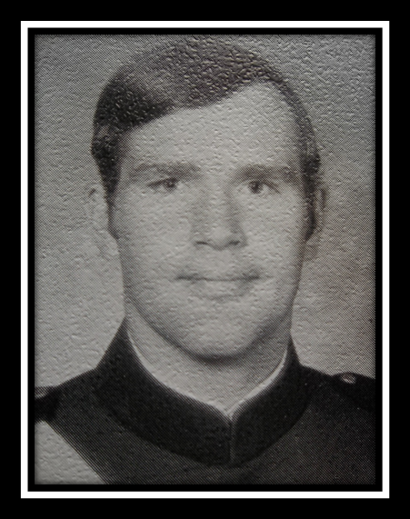

TIM HAYES
TEAM CAPTAIN
1972-1973

Tim played outside center along side of Warren Priddy. The two of them were the cornerstone of our offense and were nearly an impossible force for the opposition to contain. Tim and the rest of the 1st Classmen provided invaluable leadership and were responsible for our team’s success. Tim was the obvious choice as our team leader.

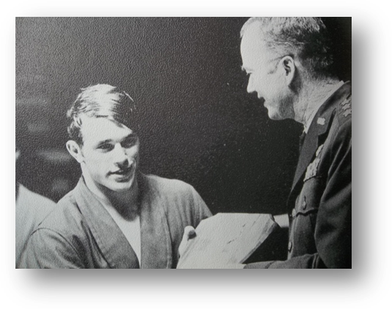
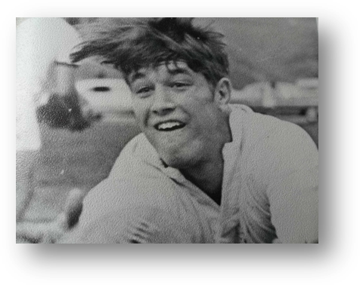
TOMMY SCHUESSLER, SCRUM HALF, ‘73
Tommy was an incredibly tough individual with very good “ball sense”. He was extremely aggressive and talented. He had the physique of Tarzan and the speed of a cheetah.

Although Tommy graduated in 1973, his picture was omitted from the 1973 Polaris year book. The top picture was from the 74 Polaris, under the intramural rugby champions. There was no mention of the Rugby Club in Polaris that year.

The bottom picture was also in the 1974 book. Was Tommy the Wing Open boxing champ? Why else would be receiving a plaque from General Clark, while wearing his bathrobe.

CLASS OF 1973

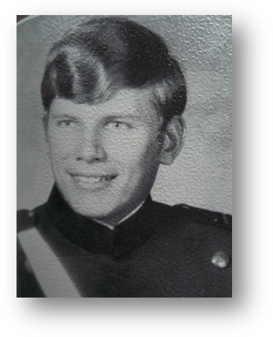
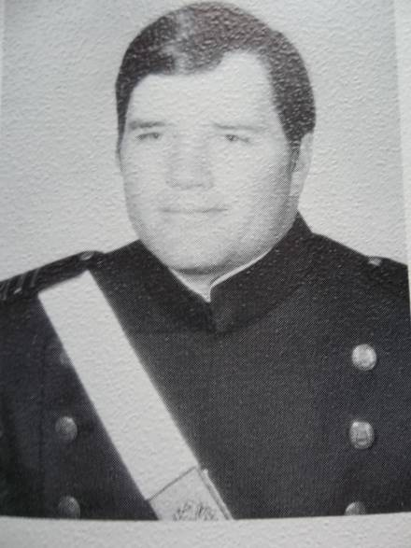

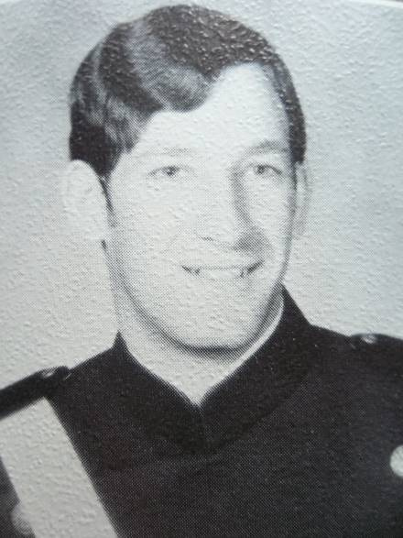
DENNY MERRIDTH, BILL DIFFLEY, AND TERRY GEERS Denny and I were in the same squadron for my 3rd and 2nd Class years. We were also teammates on the 8th Squadron intramural championship football team. Denny and I went on many a double dates and he shared his blue 240Z with me. Bill and I first met on the Wrestling team my 4th Class year. He was another of a long line of wrestlers who convinced me that collegiate wrestling was not in my future. Denny and Bill played wing forward-both were tough, fast, and very aggressive. Seldom did an opposing Scrum Half make a pass without one of them on his back. Terry was the captain of the scrum from his #8 position. He also was one of the main jumpers for line-outs. He was quiet off the field, and a leader on it.

CLASS OF 1973

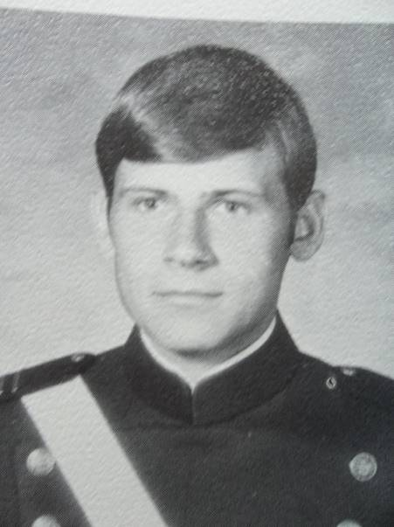

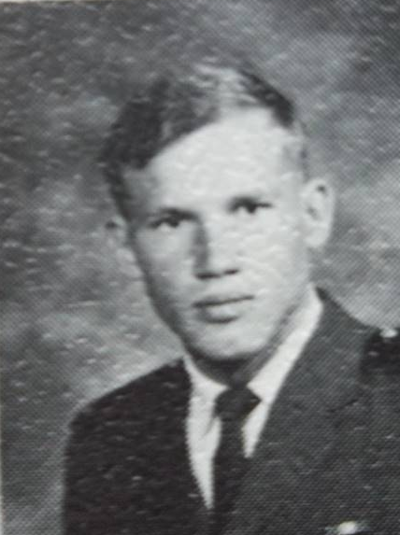
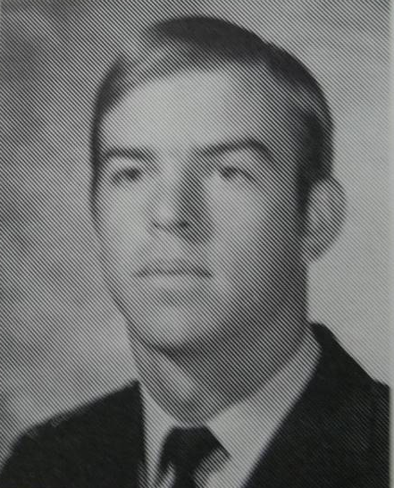
JIM YANIGLOS KAY VOLODZKO JIM SILVER

Jim Y. and Kay were invaluable to us for our epic wins at the Aspin Ruggerfest and at RAF Cranwell. They shared the Winger position and often played together as an awesome duo. Jim S. was the Hooker and threw the ball in on line outs. His fast feet, while being suspended in the air by Gary and me, allowed us to dominate the scrum.

CLASS OF 1974

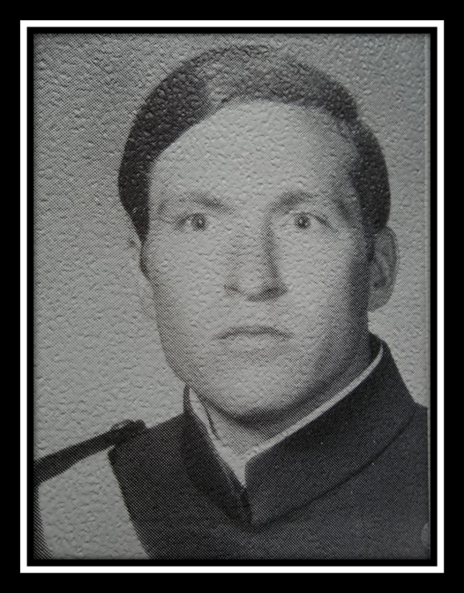

Bobby Arnold
TEAM CAPTAIN, FULL BACK
1973-1974
I first met Bobby as Doolies on the Wrestling team. We were around the same weight and we both ended up being cannon fodder for the 150-160 pound All-Americans. Even though he could kick my ass, we both decided that we were not going to make it as collegiate wrestlers. Bobby had the same attitude about the military as Donald Sutherland’s character Sgt. Oddball, of Kelly’s Hero fame. Bobby played Fullback all three years that I played, and did the kicking before “Bup” showed up. Bobby was an excellent team leader with a very strong affection for the after game gaiety.

TOM SEGULJA
Tom and I were great friends-on and off the field. I never held it against him that he bought a land yacht for his Cadet car. What else can you expect for someone from Pecos, Texas. Tom spent three years with his head up my ass and his arm around my waist as the 2nd row behind me. He played with an even fire-he was aggressive but never lost his temper. My favorite story about Tom did not take place on the Rugby Pitch, rather it took place on the intramural football field. While our squadrons were playing each other, Tom got the hit of a lifetime on me. We always had great fun going after each other, because these games were the only time we opposed each other. I was the linebacker and Tom was their guard. He faked me out-when he stood upright as if to pass block. I stood straight up and turned my head to the left, looking for the back coming out of the backfield. When I looked back to the line after I realized his deception, Tom placed the crown of his helmet squarely in my chest. With the force of a love sick buffalo, he knocked me backwards, landing squarely on the back of my neck with him on top of me. He started laughing uncontrollably, and I soon joined him. He never let me forget that event.

GARY READ Gary and I met at tryouts for the freshman football team and made all the cuts except for the last one. We met again in Rugby. Gary and I were like Siamese twin Props on the field. We were similar in size, strength, speed, and endurance. Almost always running shoulder to shoulder, I hit high and he hit low. Despite a noticeable stuttering problem, he was the team’s song leader. Gary out grew his speech problems , flew F-4’s and became a successful businessman. He was a great friend.

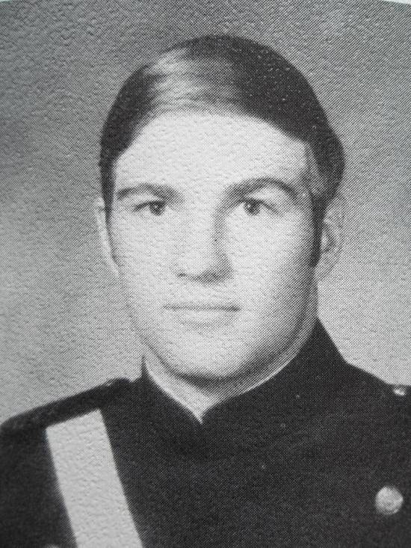
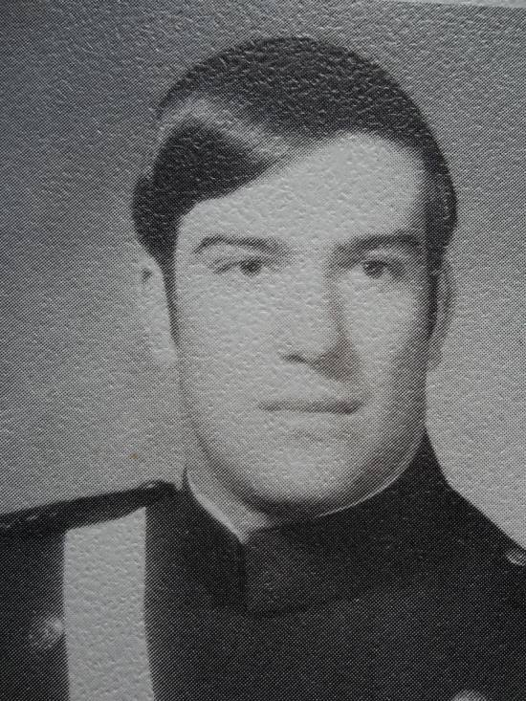

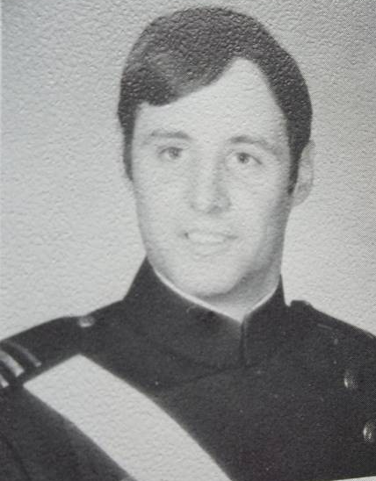
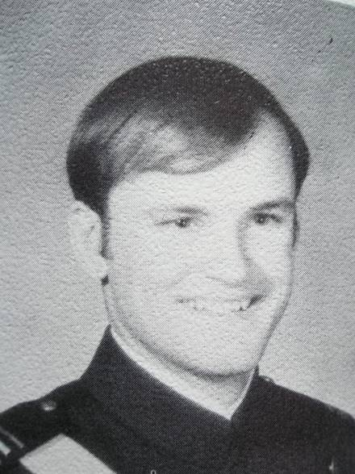
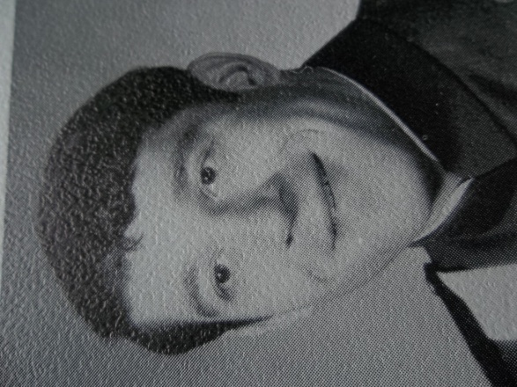
TOMMY WEISS RON WALKER

Jimmy Grandcolas, Bobby Russell, and Ron Walker were three of the bravest men I have ever met. They were undersized, almost to the point of being dangerous for them. They never backed down and always played like the champions that they were. Their speed and ball handling left opponents bewildered. They were an invaluable part of the team. Tommy could play anywhere in the scrum and was very tough. His bone structure was very heavy and his physique looked like a Marvel Super hero.

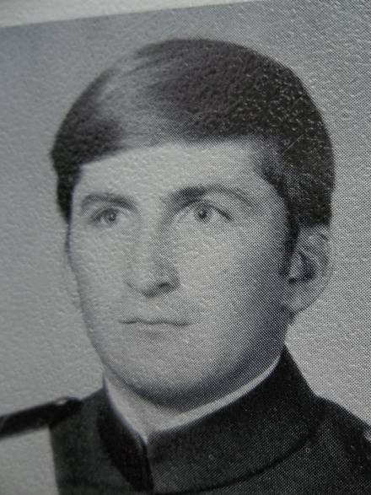
BOBBY RUSSELL JIMMY GRANDCOLAS

CLASS OF 1974

CLOCKWISE FROM TOP: JIM MEEKER, BILL MURPHY, CHUCK FITZPATRICK, AND LOUIE APPELHANS Louie was one of our best utility players, playing everywhere except interior scrum. He was an outstanding athlete and he too went on to become a successful businessman. Bill played 2nd Row behind Gary Read and Bill was the largest player we had. His chest and shoulders were enormous, even though he probably weighed no more than 230 lbs. A good athlete who rarely got excited, he was a great asset to us. “Fitz” was the human Doberman Pinscher; small head, huge body, very aggressive, and was the fastest man on the team. An outcast from the Falcons, he was a tremendous asset to us.

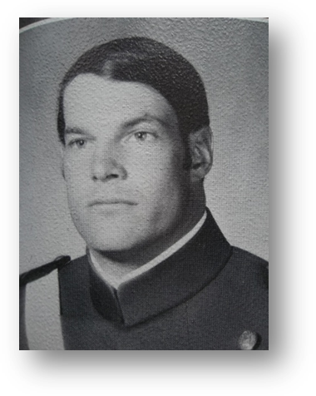
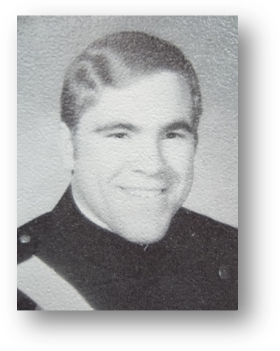

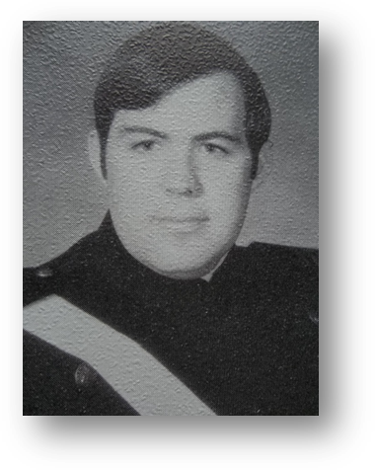
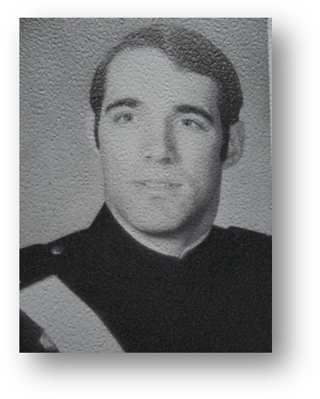

CLASS OF 1974

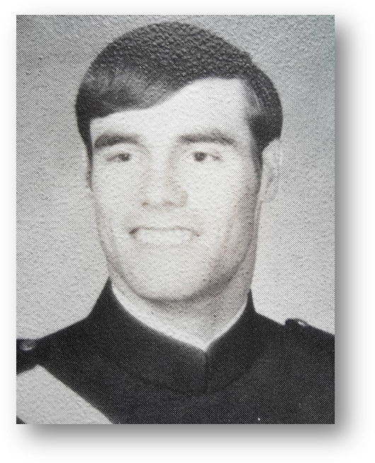
WARREN PRIDYI first met Warren at a regional track meet in the spring of my senior year in high school. Our coaches introduced us when they discovered that Warren and I were both going to the Academy. He ran the 440 yard run and just blew away the competition. A few weeks later, he set the Idaho state record with a time of 49.00 in that event. We later became very good friends through Rugby. Warren is unquestionably, the best athlete I ever played with. He was a stud! From his outside center position, he dominated the games and was feared by the opposition. Warren was the life and soul of our team; fast, strong, and incredibly durable. I saw him take shots that would make a NFL player wince, but he always got up ready to perform. I always likened him to O.J. Simpson-in between runs he looked beat up and exhausted, but when he got the ball, he was always 100%.

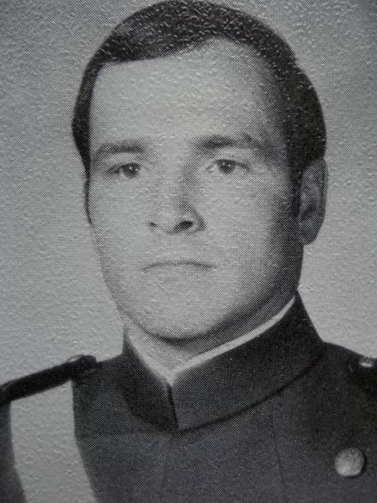
BRUCE “BUP” BERRY “Bup” either played one of the center positions or played winger. However, he was most valuable as our kicker. He had incredible success during his tenure, winning numerous games for us with his foot. Small in stature, he was a strong runner with an even stronger right leg.

CLASS OF 1974

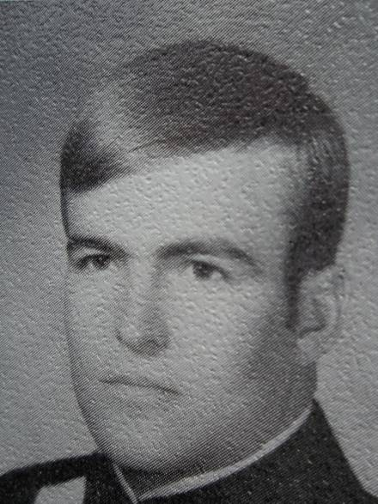
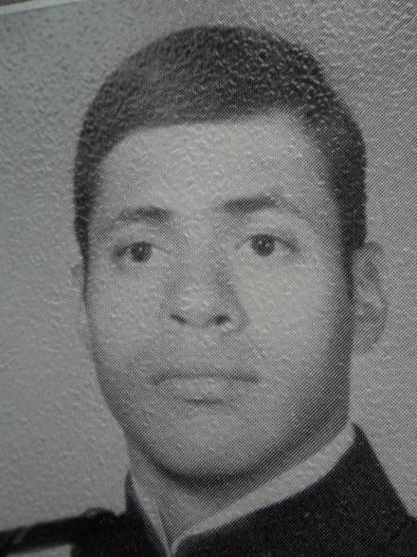

MIKE MAQUET VIC COLLAZO
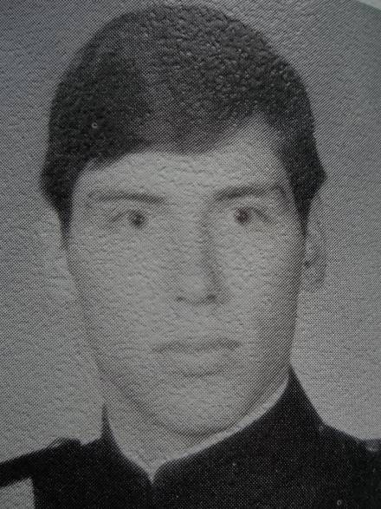
Mike, Vic and Nate usually played on the B Side. While they were not starters, I always admired their loyalty and dedication to the team. Their love of the game was readily apparent and they made significant contributions to the team. Nate has been very active in the Alumni Association and has made significant financial contributions to it. Vic is the center of one of the Rugby Club’s greatest mysteries: how did he end up the Keeper of the Aspen Ruggerfest Team trophy for over 30 years? I did not know one even existed! Mike was the “straightest” military man on the team, even though Bobby Russell and I were Squadron Commanders. He was respected and his presence added greatly to our team. His senior year, he always traveled with the A Side, and was a dependable utility injury sub.
NATE ROSENBERG

CLASS OF 1974

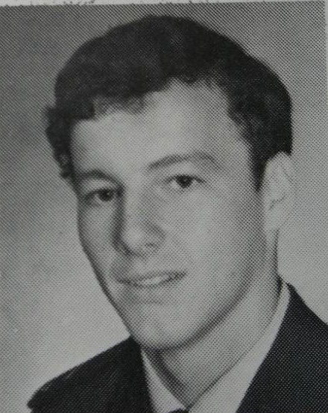
Steve was an excellent utility player, substituting during games and he started numerous games while filling in at any back position. Steve traveled with us to RAF Cranwell as well as the Aspen Ruggerfest. Paul was an excellent Fly Half, starting many games. Unfortunately for us, Paul left the Academy after his 2nd Class year.

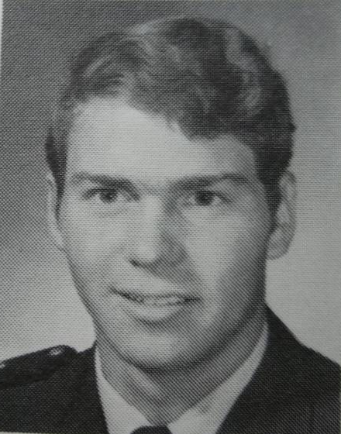

STEVE LUNSFORD

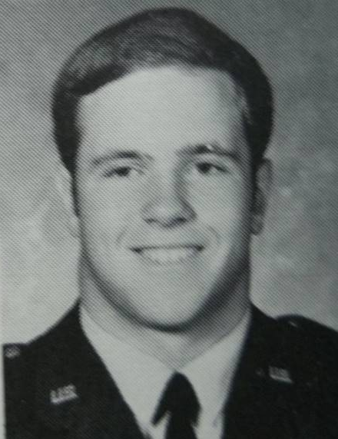
PAUL DOOLEY

Dave was 2nd Row, behind Gary Read for the 1972-1973 season. He was the biggest man on the team and he played like it. He left USAFA after that season, making way for Bill Murphy. I really liked playing with him.

DAVE ROWAN
CLASS OF 1975

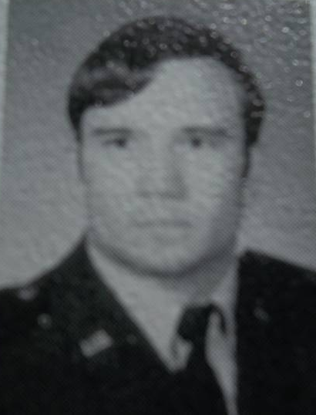
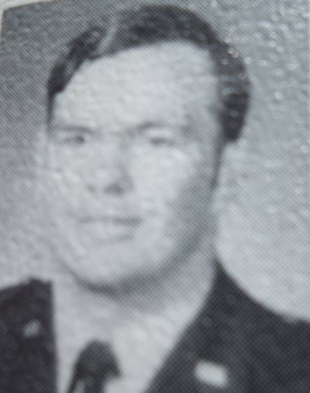

RICK BENBOW MIKE DELONEY

CLASS OF 1975

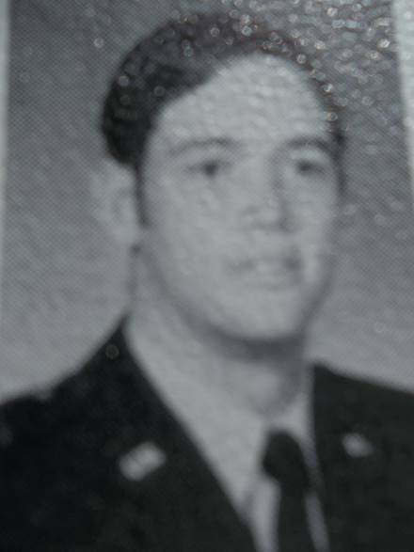
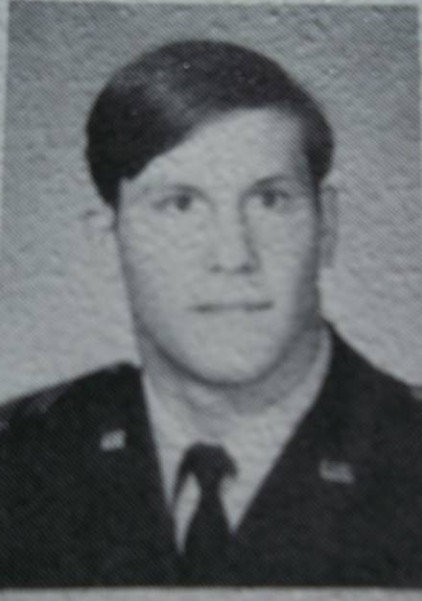
DANNY WOOCK “SHEP” SHEPPARD

CLASS OF 1976

I think Sal was the Hooker my 1st Class year. When you “hang” around with someone for a whole year, you would think that I should remember for sure.
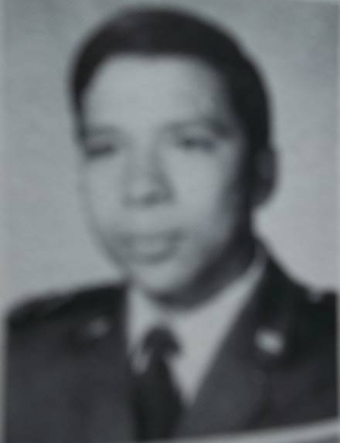

SAL REZA

JIM E. CARTER

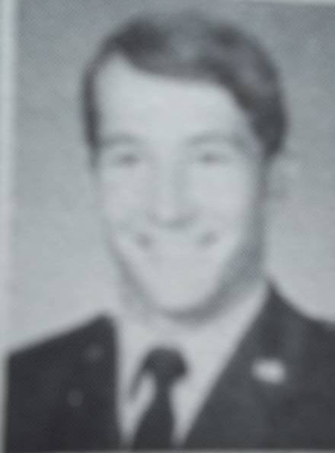
Jim was the Scrum Half my final season, replacing Tommy Schuessler. He was a quick learner and became the “quarterback” of the team. Although smaller than Tommy, his ball handling abilities, quickness, and mental toughness became valuable assets for the team. In 1981, Jim and I were assigned together in the 704th Tactical Air Support Squadron, Sembach Air Base Germany, flying OV-10’s and sharing Ground FAC duties. Even though we have lost touch over the years, our families became great friends for those two years.

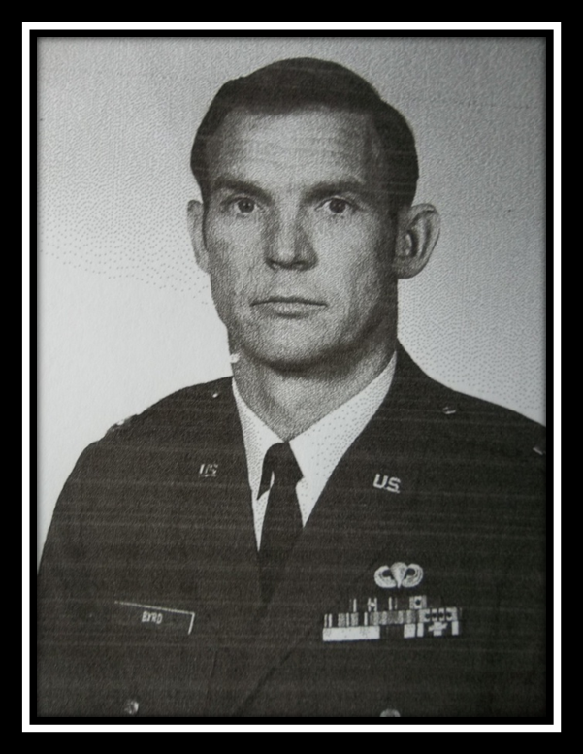

COACH TEX BYRD
1971-1975

Tex was my coach on the B Side as a 3rd Classman and my coach on the A Side my 2nd and 1st Class years. As a Cadet, most Officers were feared in public and ridiculed in private. Tex was different. He treated us with caring and compassion, always finding time to council and to guide us. He made a very difficult time in our lives bearable by acting as our surrogate parent or sibling, and he always kept the door of his home opened to us, for parties or for a much needed sanctuary from Academy life. His family became our family. I was so proud of his son Matt, then 10 or 12 years old, when he went on to play Academy Rugby. He outdid all of us by becoming a Thunderbird pilot and successful businessman. I met countless Officers in my career, and served several years as a General’s aide, but no one ever exemplified what an officer and gentleman should be, nor did they ever command the respect from his subordinates that Tex did. I have always looked up to him and have tried to live life as I envisioned he would do. No other officer I met along the way did that for me. Thanks Tex!

ASSISTANT COACHES

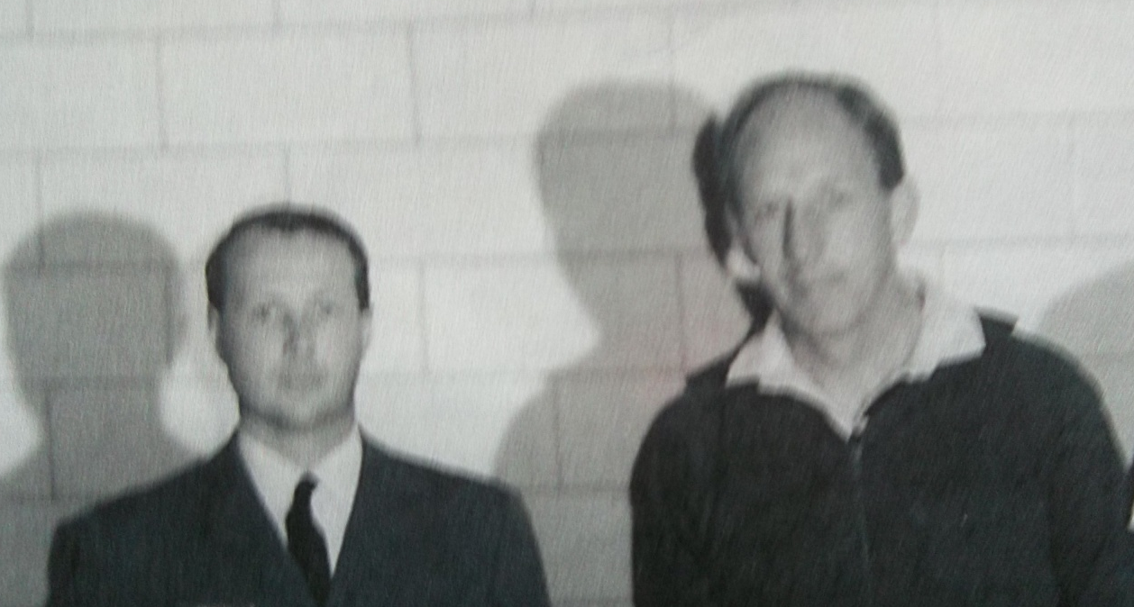

SQUADRON LEADERS DAVID STABLES AND
BRIAN REYNOLDS

Stables and Reynolds were on loan to us from the Royal Air Force and replaced Wing Commander Tony Mason as British Ambassibors on the team. I believe Brian took over for Tex as Head Coach at the end of the 1975 season.

PHOTO

ALBUM

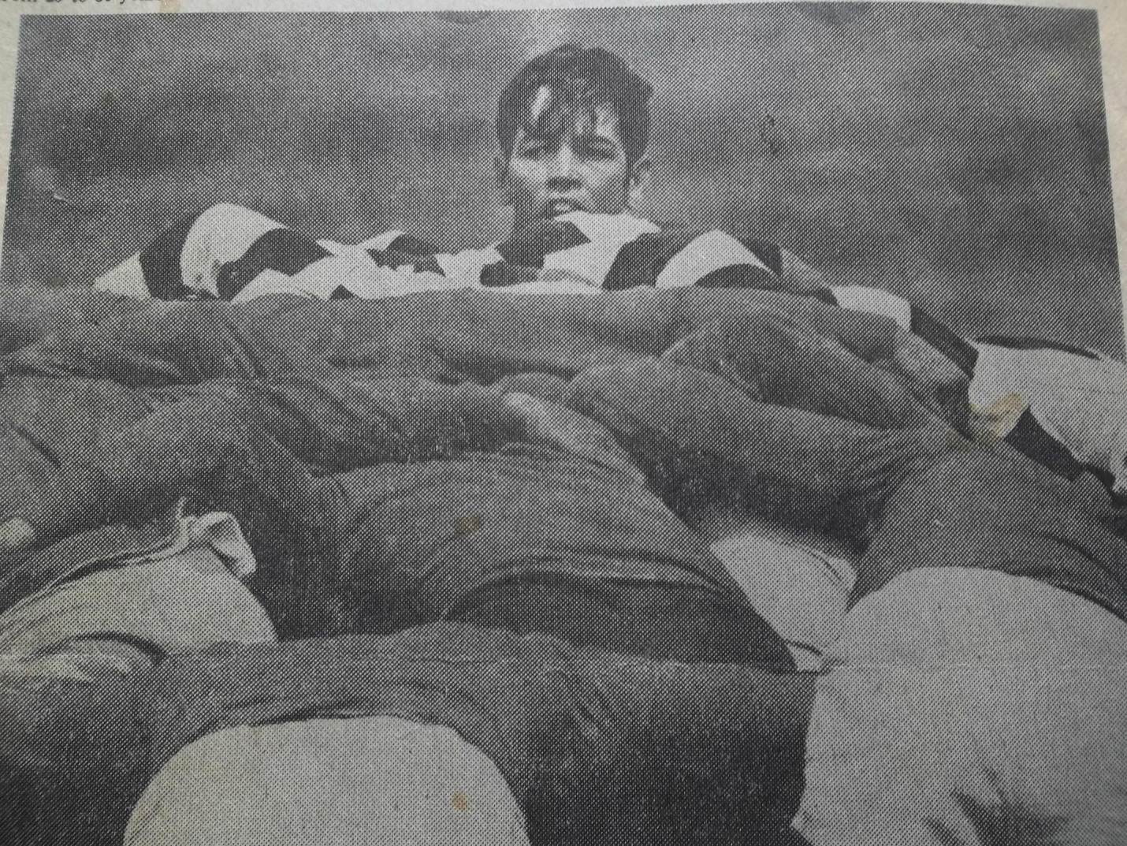
“Shep” Sheppard is seen peering over the scrum in a photo by the Colorado Springs paper.
1973-1974

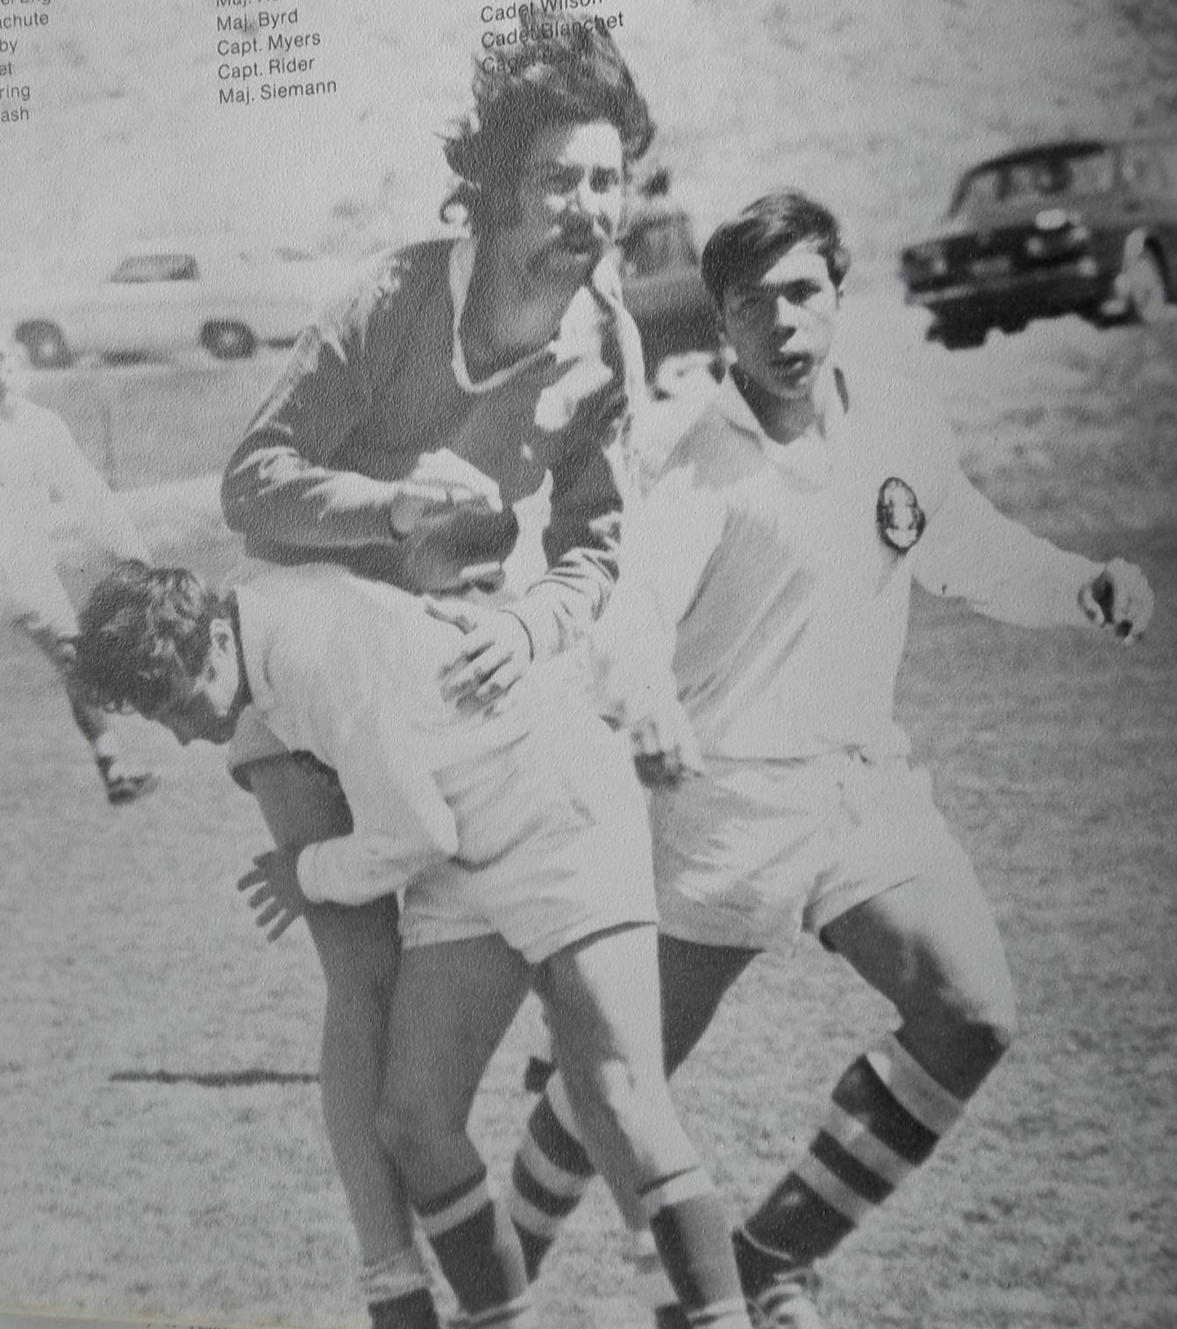
This photo appeared in the 1974 Polaris. Jimmy Grandcolas is tackling a Denver Barbarian, with Sal Reza looking on.

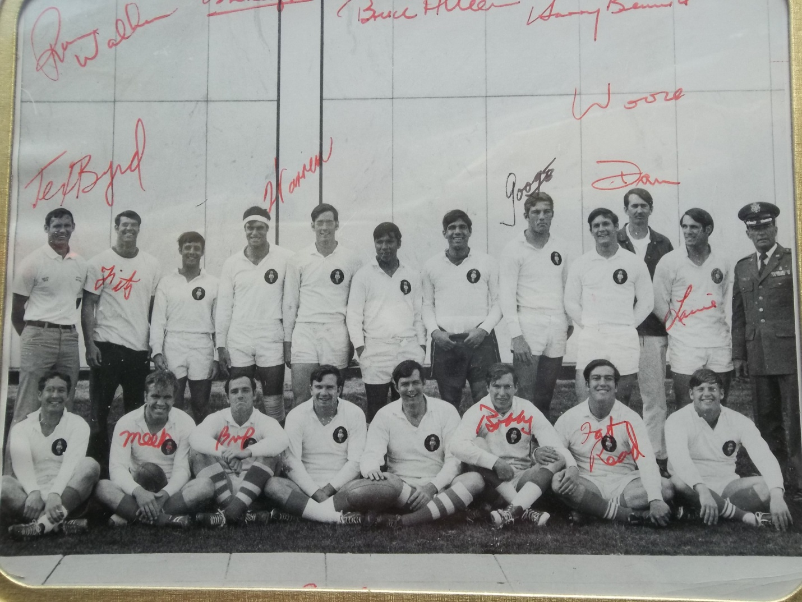

TEAM PHOTO OF 1973-1974 A SIDE. FRONT ROW: JIM CARTER, JIM MEEKER, ‘BUP’ BERRY, MIKE DELONEY, BILL MURPHY, BOBBY ARNOLD, GARY READ, AND UNKNOWN. BACK ROW: TEX BYRD, “FITZ” FITZPATRICK, JIMMY GRANDCOLAS, WARREN PRIDDY, “SHEP” SHEPARD, SAL REZA, UNKNOWN, TOM SEGUILJA, DAN WOOCK, DAN ELLISON, LOUIE APPELHANS AND COL MANDY BAIRD.
T

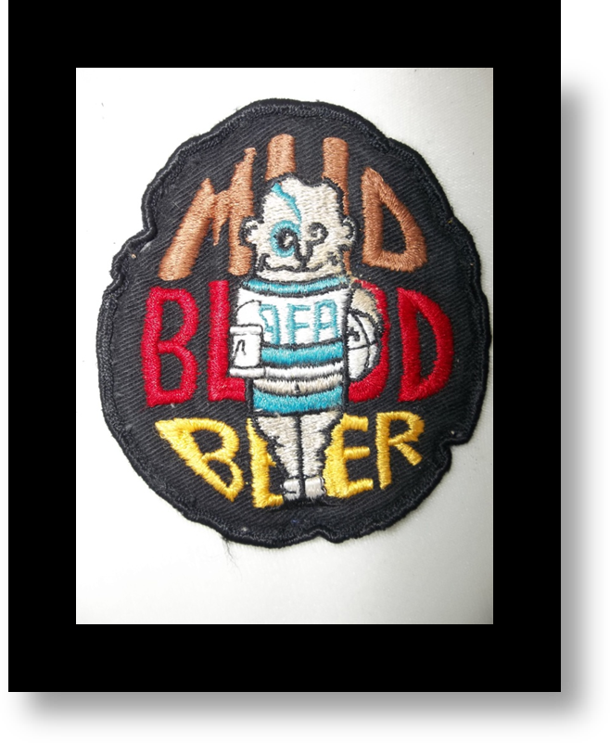

“Mud, Blood and Beer”, this is a photo of the patch that I wore proudly on my left breast during the 1973-1974 Rugby season. It is more than a patch, it is a symbol for all that has gone wrong in our society since 1974. When Tex left the Academy in 1975, the patch left with him. The new coach (and I am sure the Academy hierarchy), wanted to clean up the team’s image. In my mind, that was a mistake. That patch served as a reminder as to why Rugby is different from all other sports. It is the only sport where the teams socialize immediately after the game, share stories, and become friends, at least until you see them on the Pitch again. Playing Rugby without the craziness that followed, is like eating lettuce and calling it a Caesar Salad. It cannot be the same. In those days, I did not drink beer at all, but I could sure hold one and enjoy the party, sing the songs, and if called upon, be the Zulu Warrior. Taking the patch and cleaning up the image, was the first shot across the bow for Political correctness. It was the first step in a lifelong march to make warriors presentable to the rest of society. While we were being trained to kill for our country, we were always expected to march to the tune of Political Correctness.
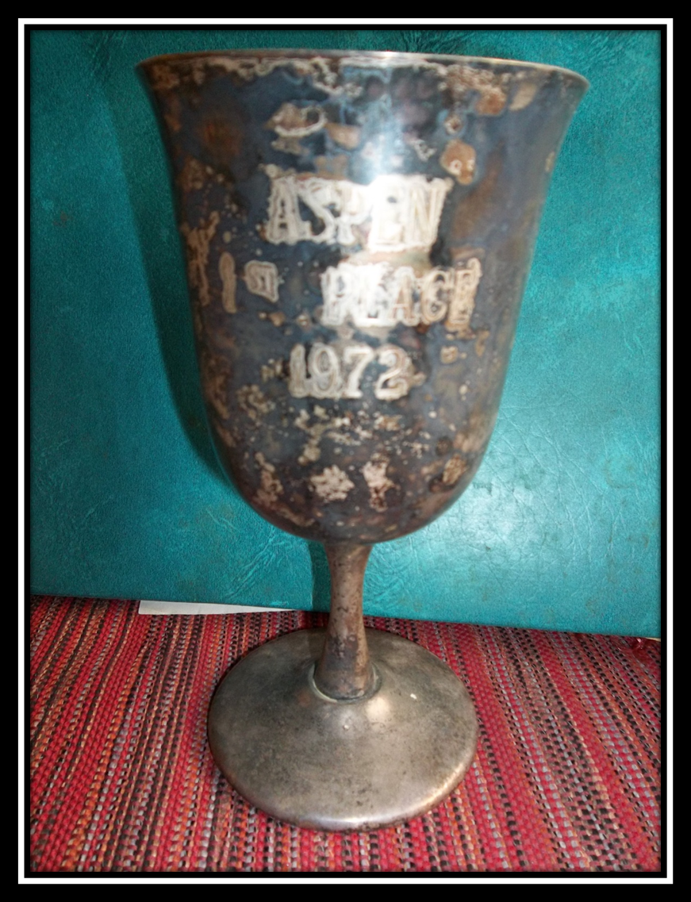

THE ASPEN RUGGERFEST 1ST PLACE CUP
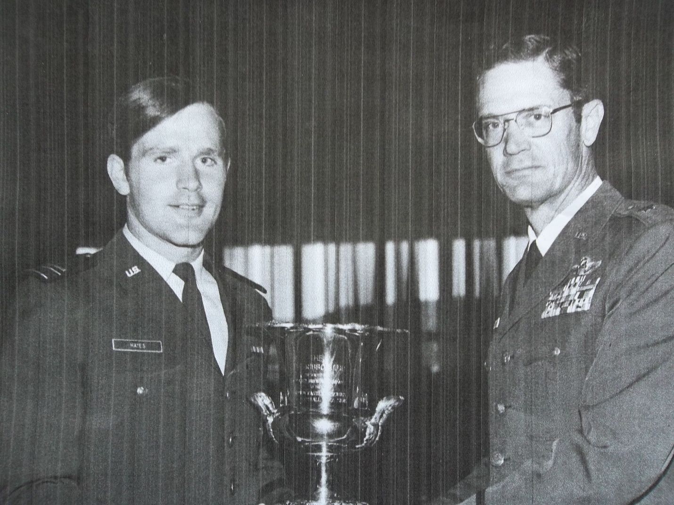

BG Hoyt Vandenberg presenting Team Captain Tim Hayes a trophy from Mitchell Hall tower during lunch. it is unknown what the trophy was for, possibly the Rugby Union Championship or the Aspen Ruggerfest trophy. The General filled the trophy with donations from his Staff for the Club’s Beer Fund.

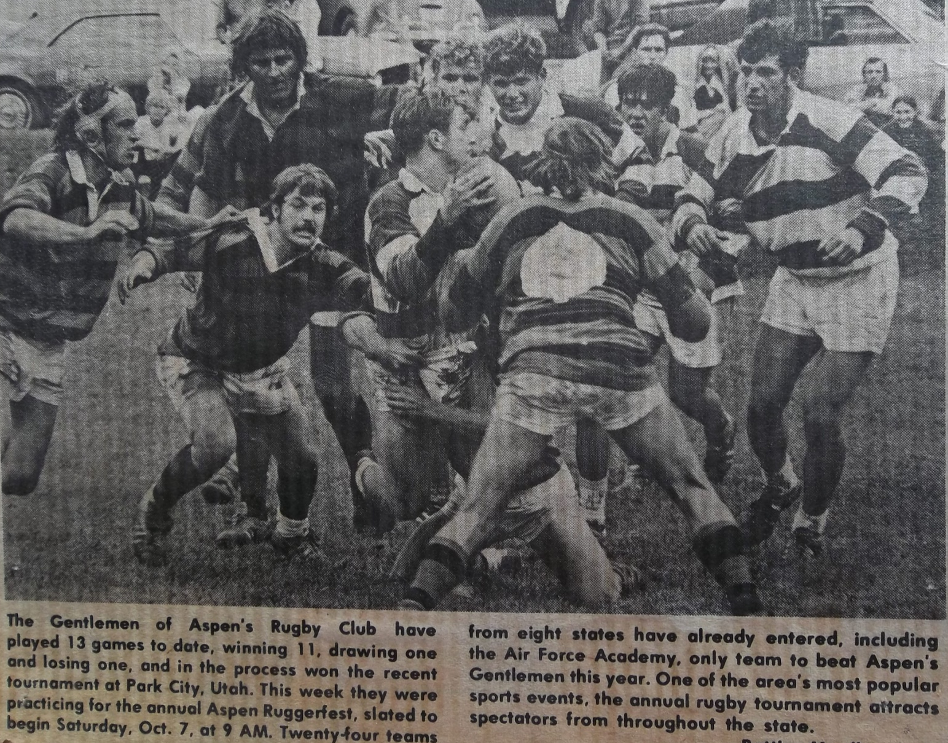
In the fall of 1972, we traveled to Aspen, this time to win the Ruggerfest. Pictured are Tommy Schuessler (with ball), Jim Meeker (center, over Tommy’s head), Denny Merideth, Gary Reed and Terry Geers (on right).

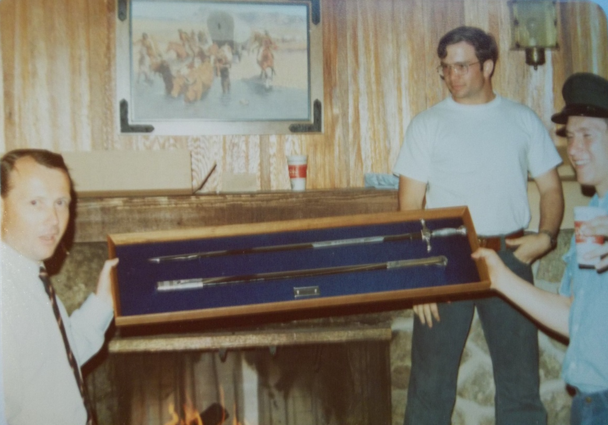

Just before graduation in 1974, we had a party to say “good bye” to Squadron Leader David Stables.
Squadron Leader Stables was “selected” by General Vandenberg to perform the sacred rite of ZULU WARRIOR. Although reluctant, he performed his ancient duty.

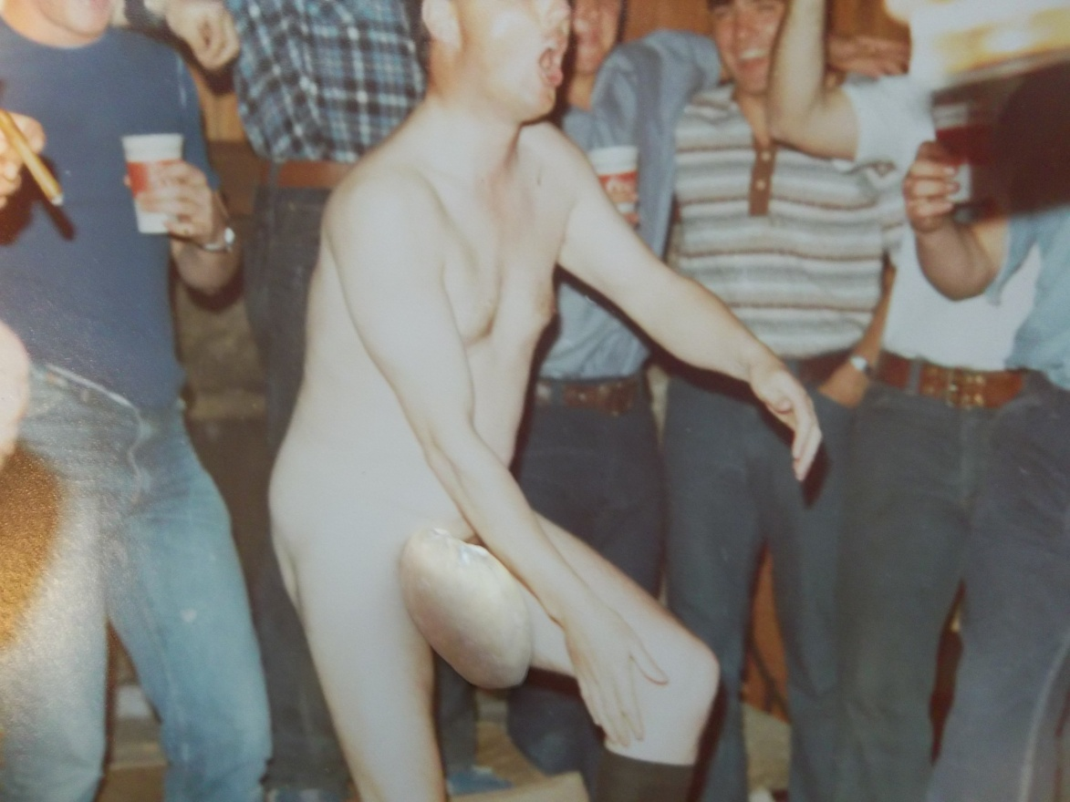

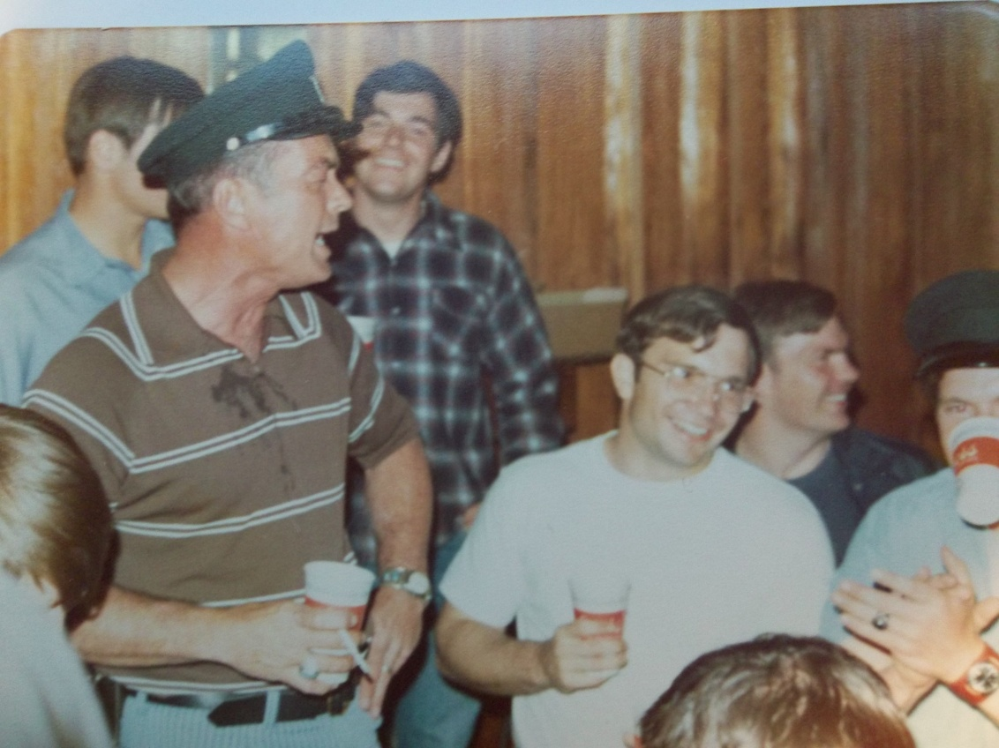

Col Mandy Baird supervising a party, while singing “Balls to the Wall”.
Col Baird is also demonstrating that beer can be a powerful fashion accessory.
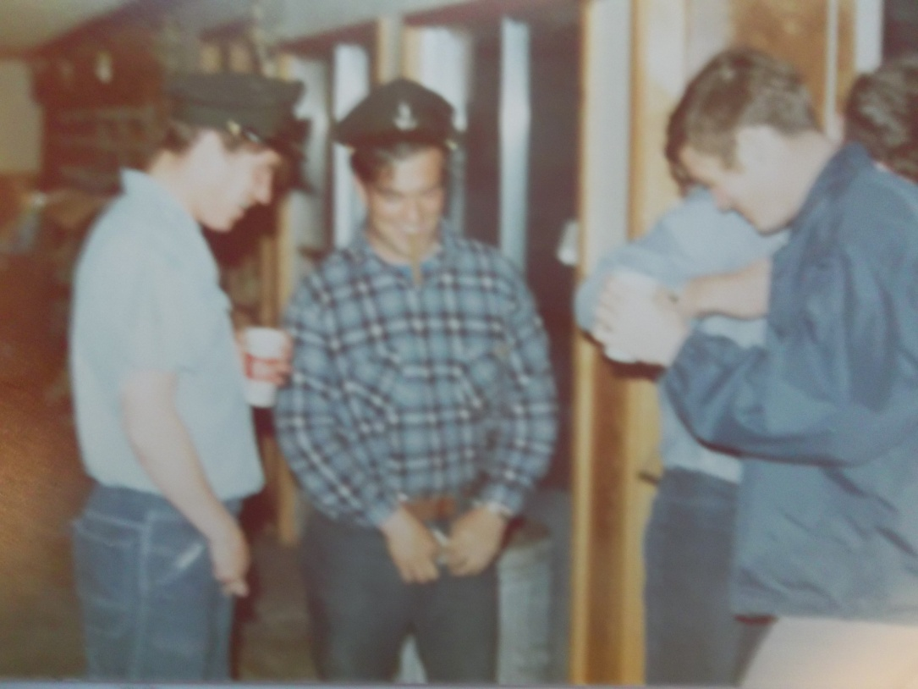
Bobby Arnold and Shep Sheppard watch as Gary Read shows them the fine art of “exposing”.

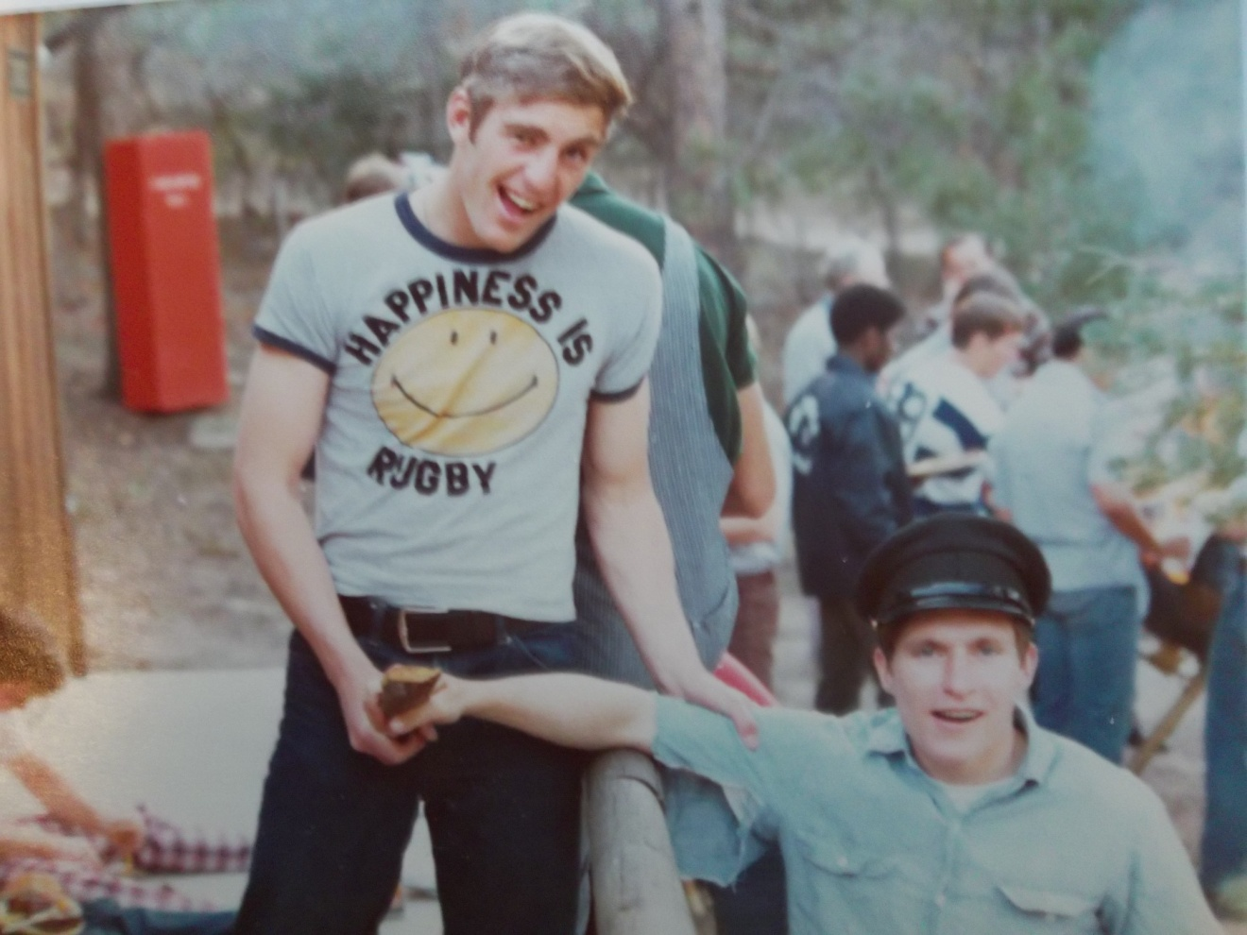
Bobby Arnold and Tom Segulja are captured enjoying a special moment.

“Meek” and “Googe” admiring Tom’s land yacht.
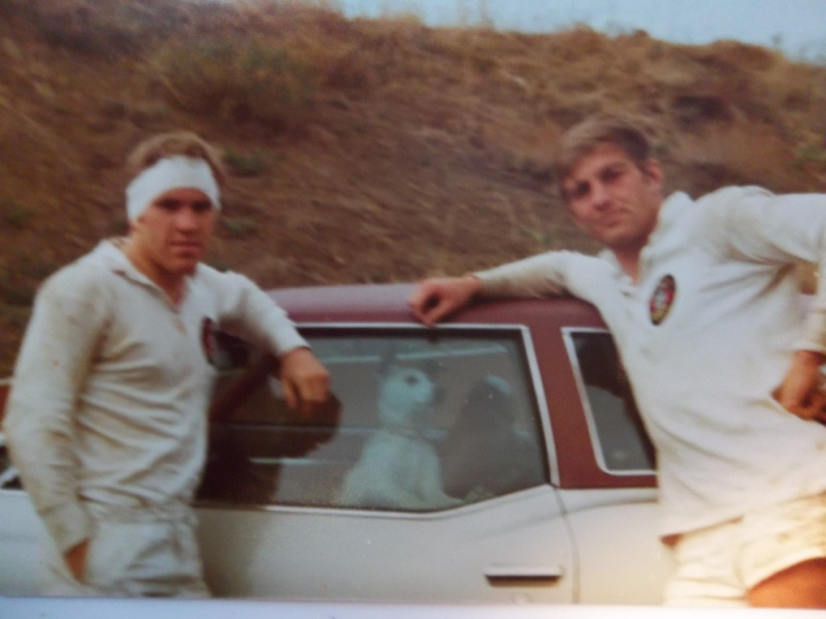
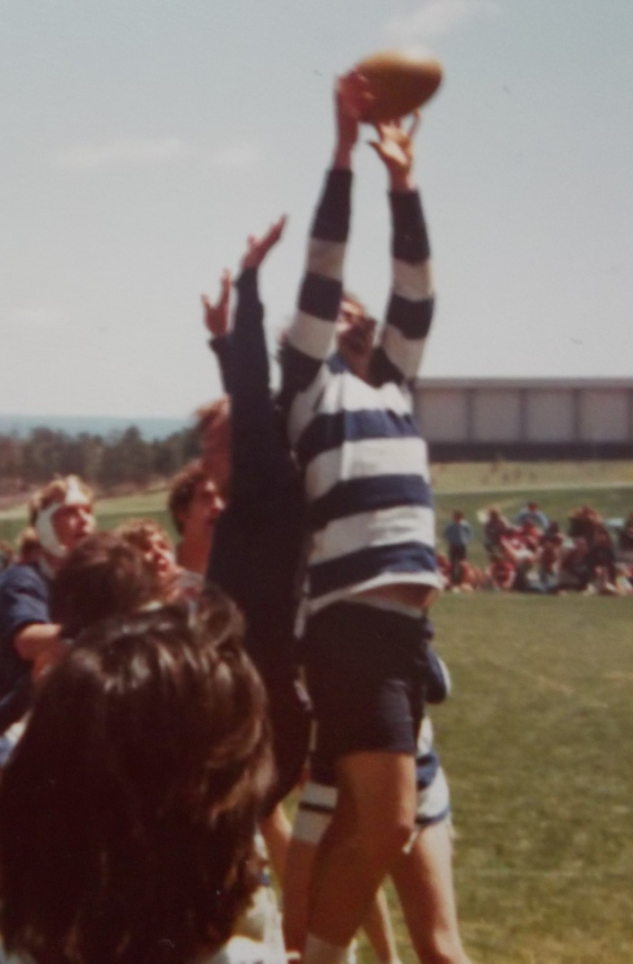

TOM SEGULJA WINS ANOTHER LINE OUT.

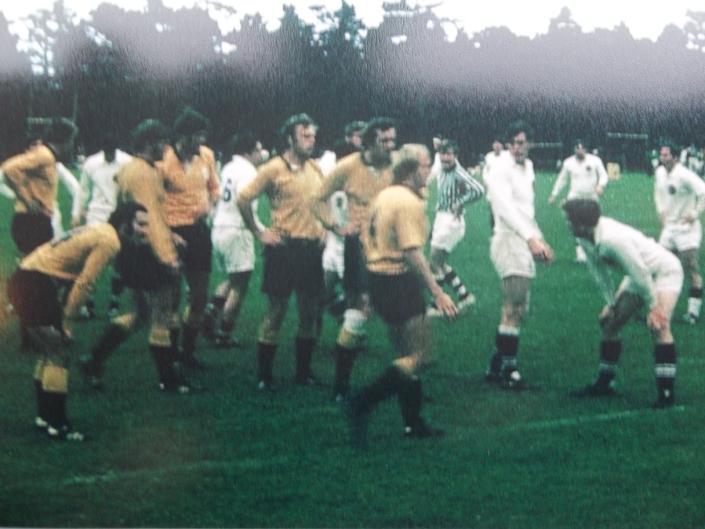
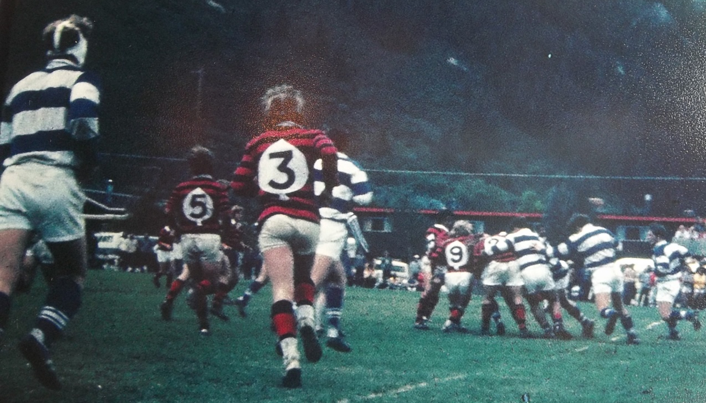

Aspen

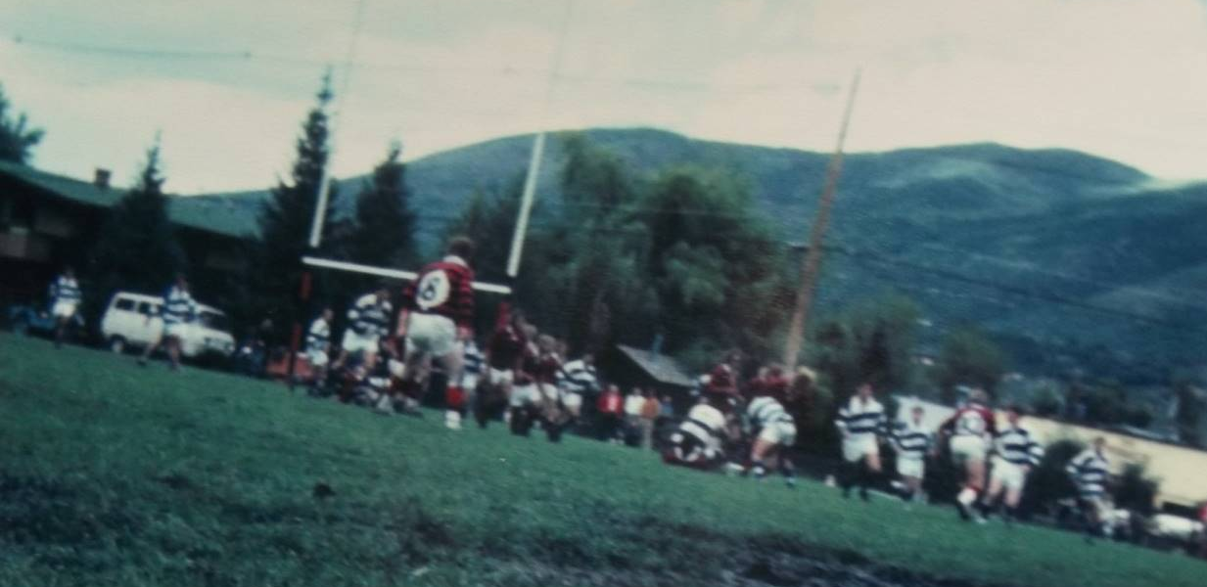

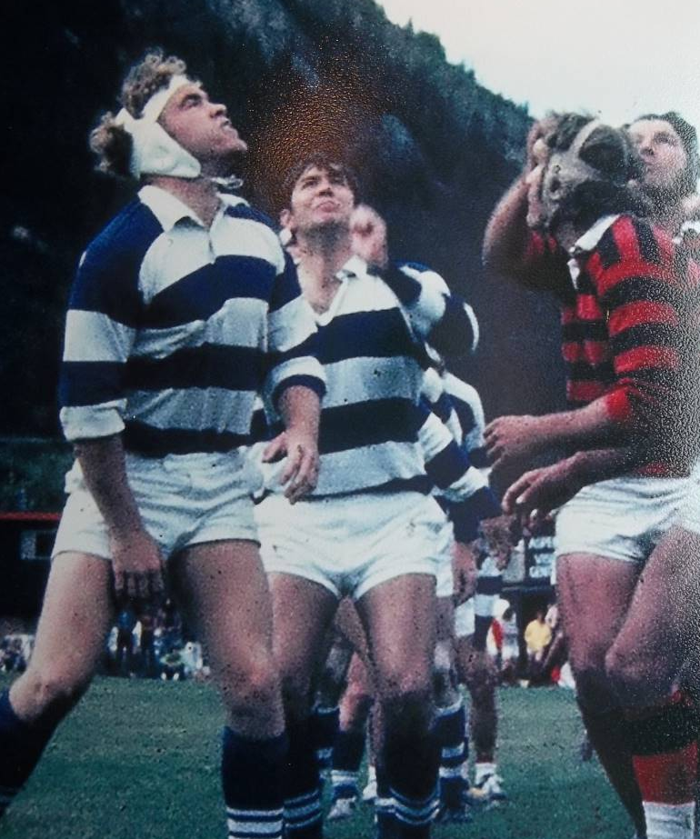
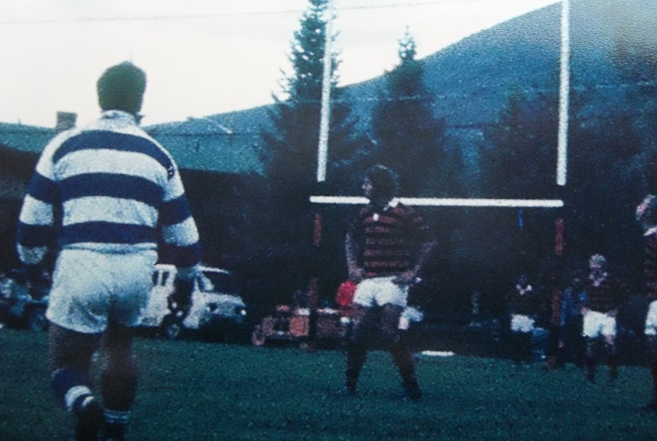
Aspen

“BUP” BERRY SCORES ANOTHER KICK.
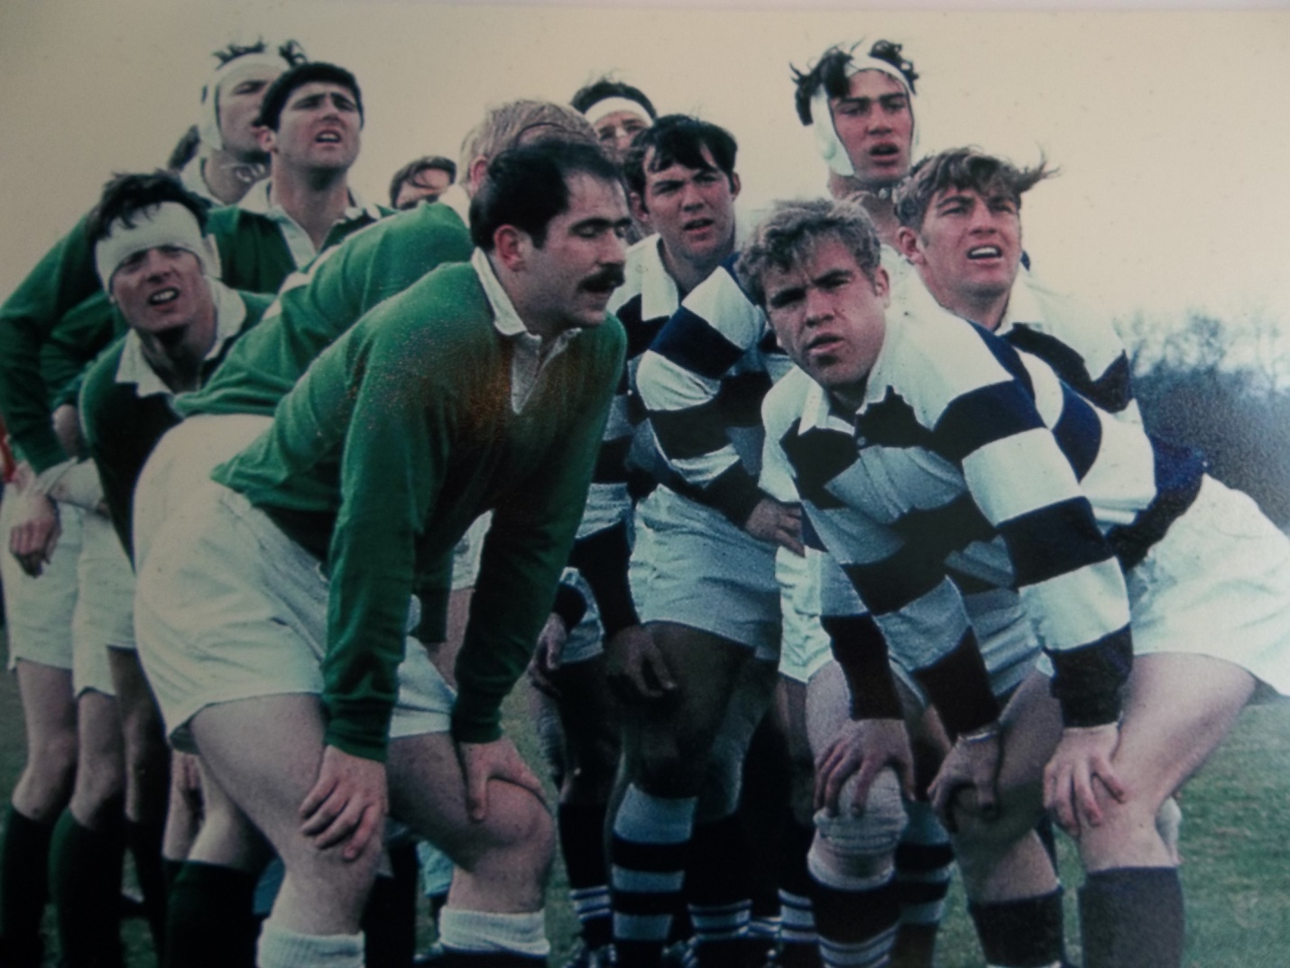

Our arch enemies-The Denver Barbarians

A line out in Denver showing Jim Meeker, Tom Segulja, Gary Read, and Bill Murphy.

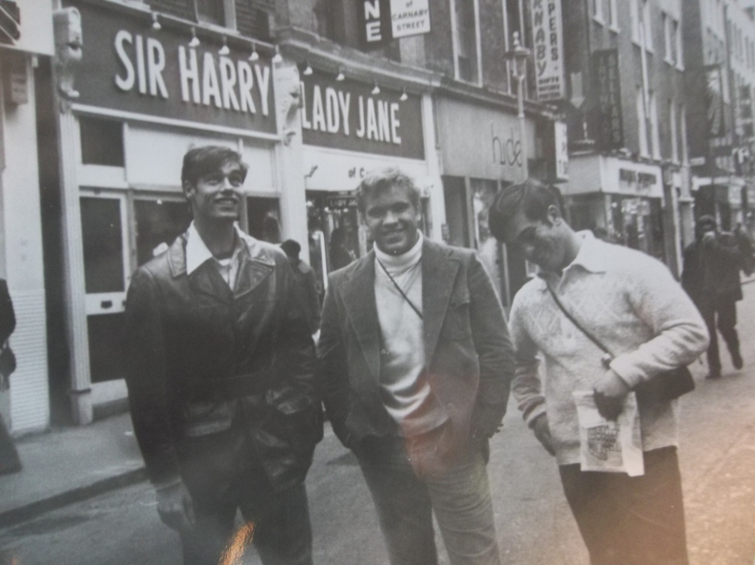

Small town boys loose in the streets on London!
RAF CRANWELL, 1973
Warren Priddy, Pierce, Idaho (pop. 400); Jim Meeker, Bonners Ferry, Idaho (pop. 1925); and Gary Read, Macksburg, Iowa (pop. 125). This is the photo that the street photographer promised to mail to us for 10 pounds each. After a year, it showed up in our mail boxes.

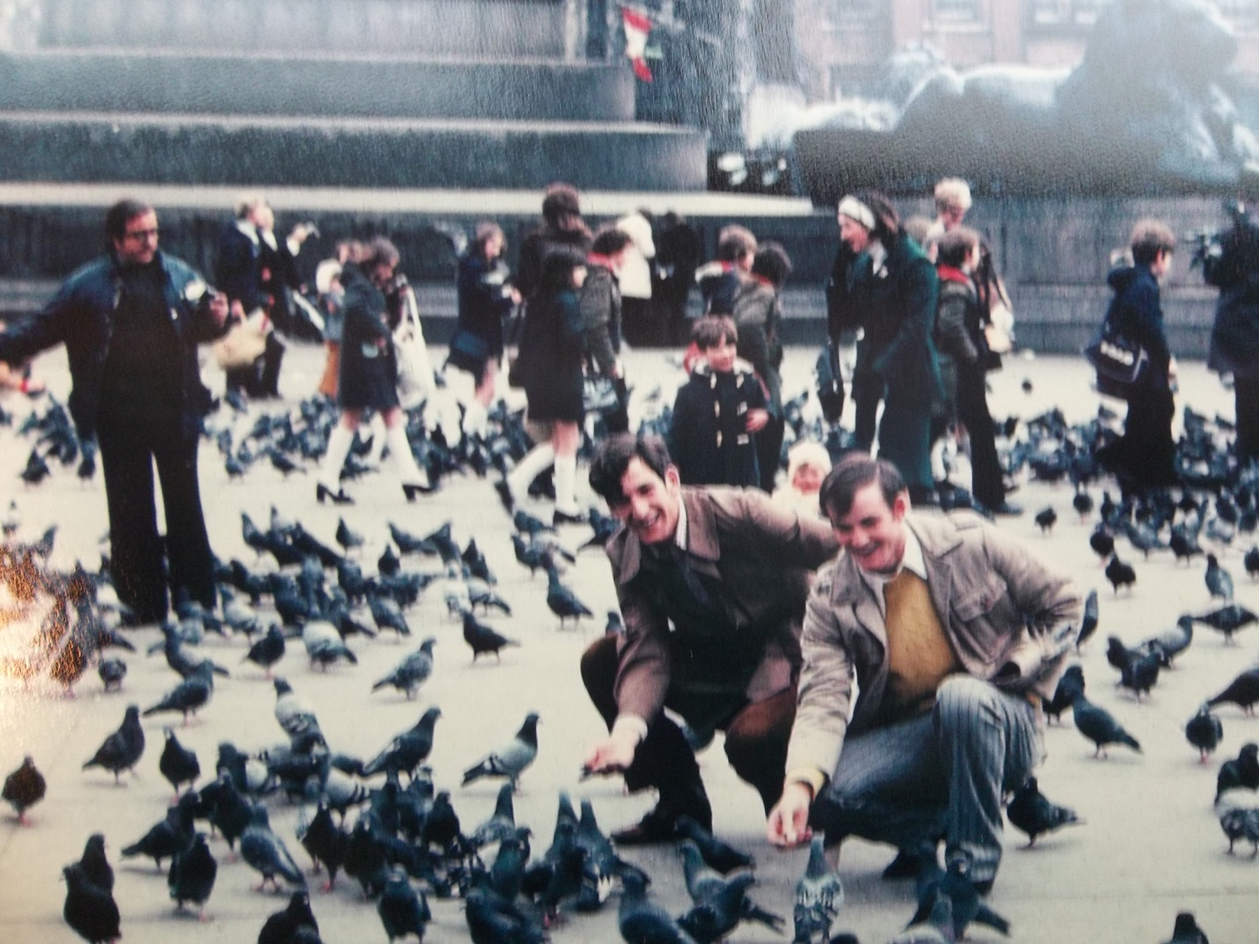
Terry Geers and Bobby Russell feeding pigeons in London.
RAF CRANWELL, 1973

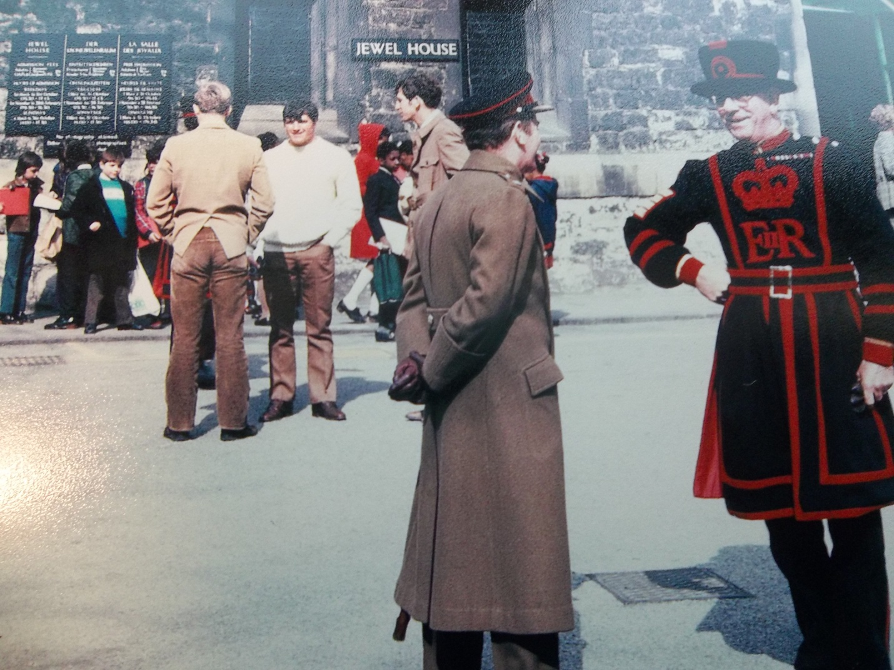
Tim Hayes, Bill Diffley, and Terry Geers in front of the Tower of London.
RAF CRANWELL, 1973

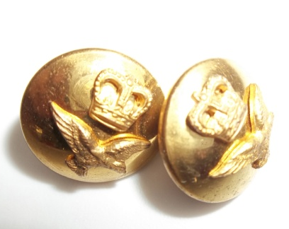
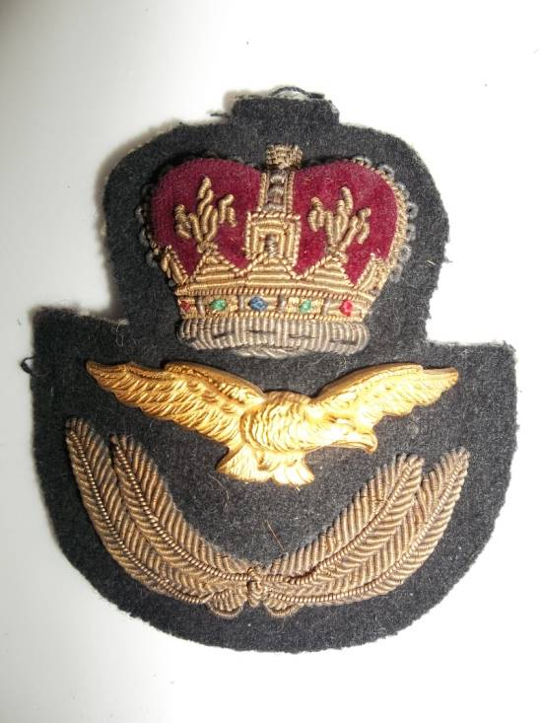
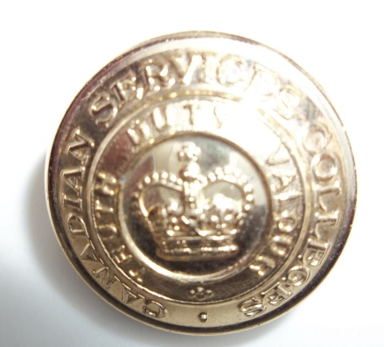

Souvenirs from Royal Roads Academy: Hat emblem, cuff links and blouse button.

MILITARY UNIFORM ITEMS WERE EXCHANGED AT ROYAL ROADS AND RAF CRANWELL.

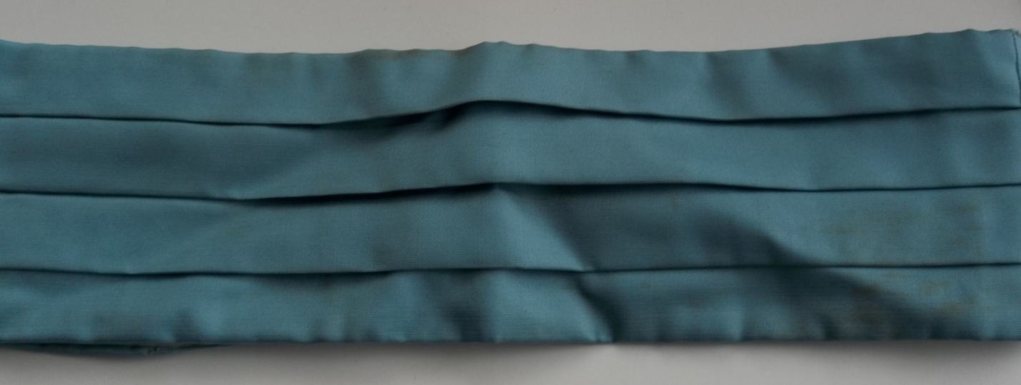
Medium blue cummerbund obtained at RAF Cranwell.
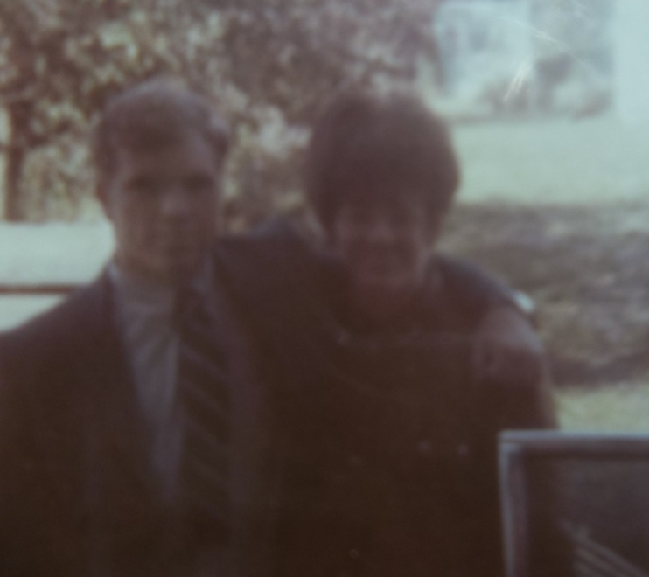
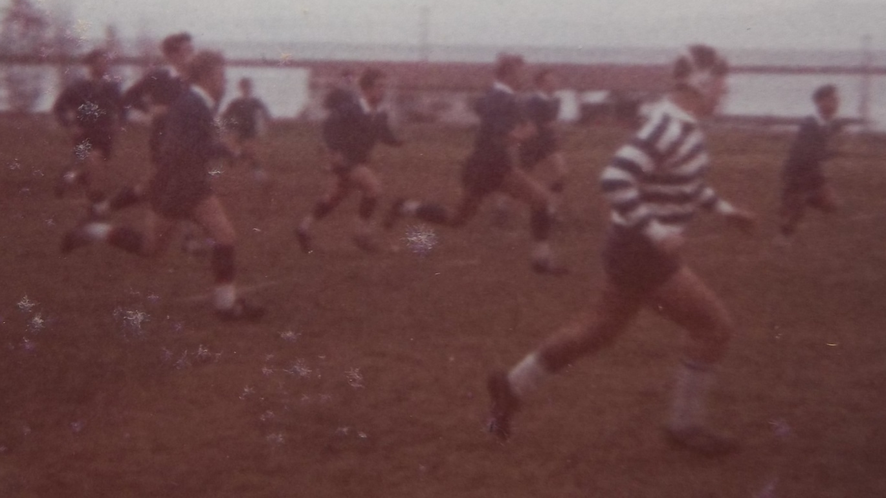
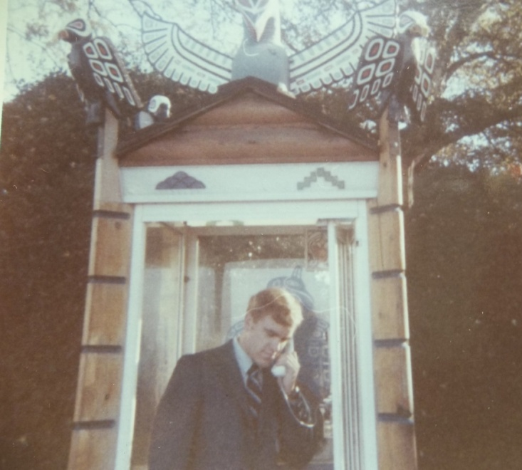 Here I am posing in a Canadian phone booth. My sister Pat and brother Dan drove to watch the game.

Royal Roads, Fall 1971

This is the only picture I have of the game. Jim Meeker (3rd from left), Gary Read, and Tom Seguilja.

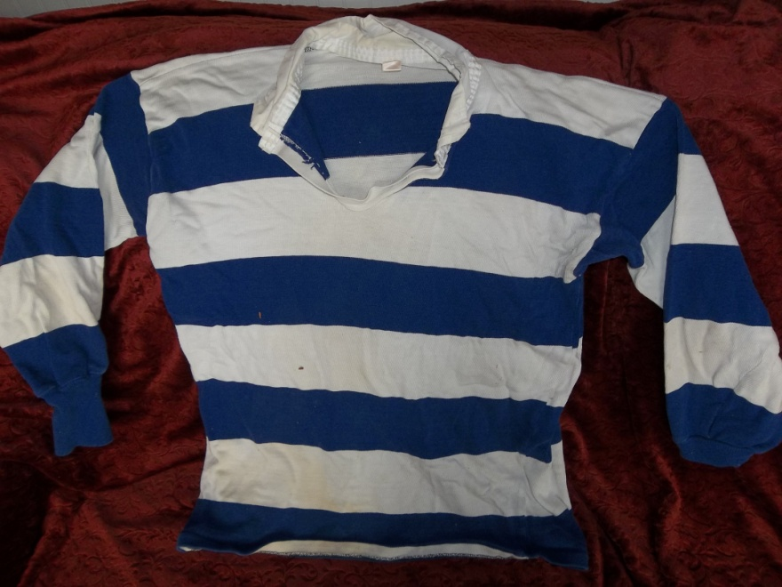

Blue and white jersy from the 1972-1973 season

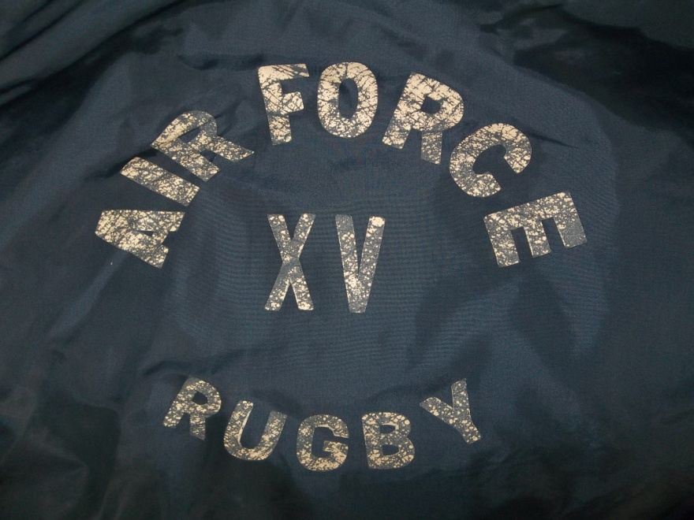
Windbreaker warm-up jacket

20TH REUNION, 16 SEP 94
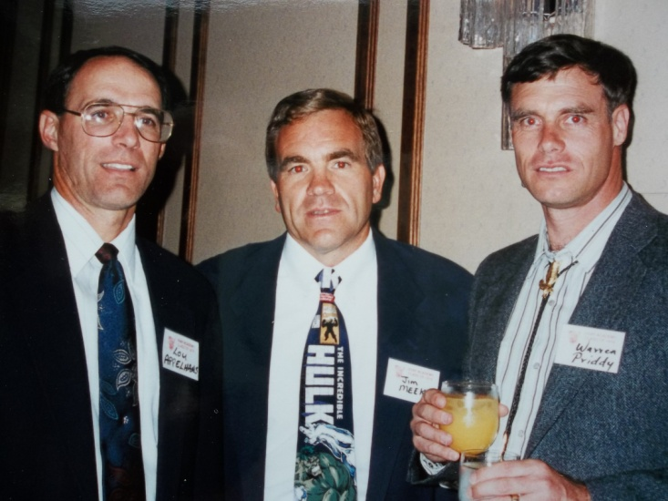

LOUIE APLEHANS, JIM MEEKER, WARREN PRIDDY WARREN WITH DEBBE MEEKER
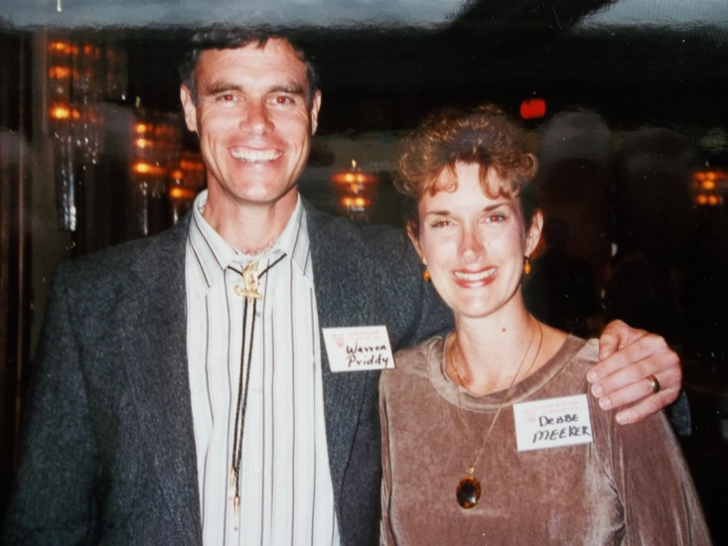

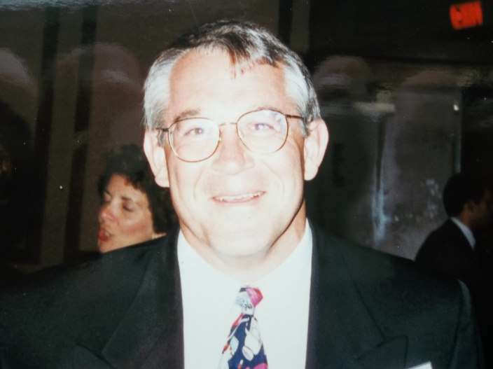
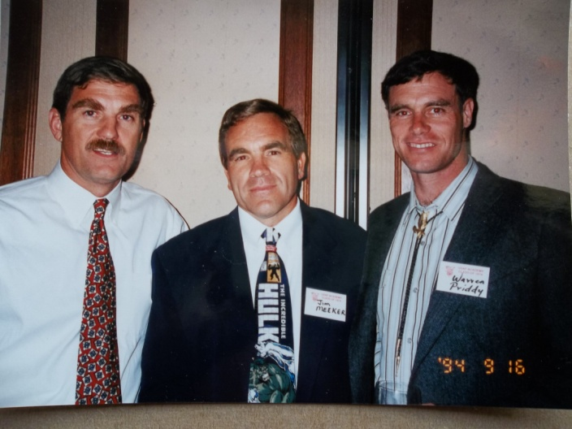 TOM SEQUILJA, JIM MEEKER, AND WARREN PRIDDY TOMMY WEISS

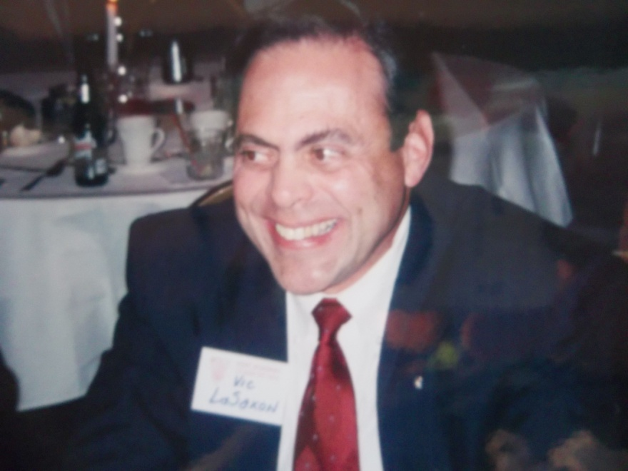

VIC CALLAZO (LaSAXON)

