Meet your AFA Affinity Group Board and Officers

Terms expiring in 2018

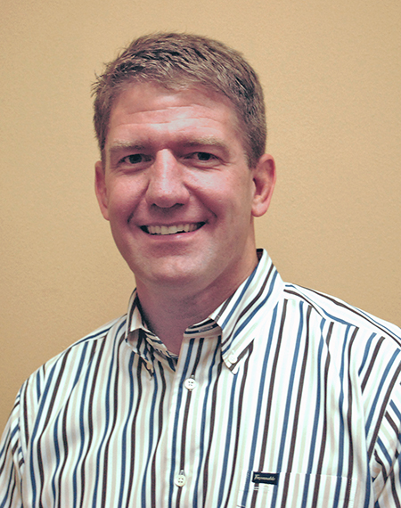
Dan Drummond, ’89. Chief Marketing Officer, Bar Louie, with 14 years of post-military marketing and leadership expertise. He played on the 1989 National Collegiate Championship team (2nd Row/#8) as well as the USAF team that took the Military Championship the same year. He has toured Japan, Australia and New Zealand representing the Air Force and Combined Services and has been a member of teams in Sacramento, San Antonio, Northern VA (NOVA) as well as a member of Battock’s Bombers. He has prior board experience with Share Our Strength’s No Kid Hungry, Big Brothers Big Sisters of Central Arizona and Allied Information Systems.

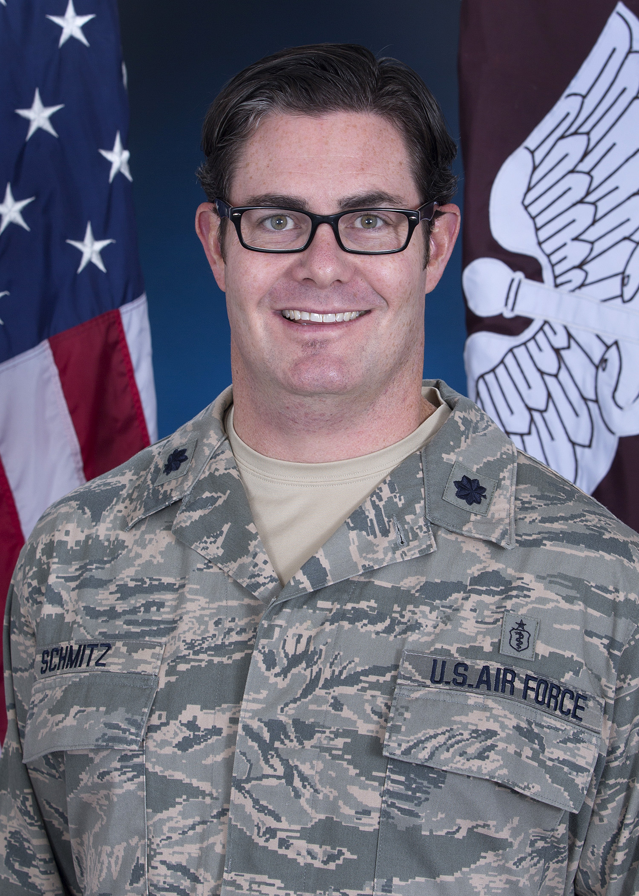
Lt Col Matthew Schmitz, M.D. ’00, served as captain of the USAFA rugby team in 2000. He went on to play in the US Super League for the Chicago Lions from 2000-2004, representing the Air Force Selects in 2000 and was a Midwest All-Star 2001-2004. He was a member of the USA Eagles who traveled to Russia in the 2003 Super Powers Cup. Dr. Schmitz is now the Chief of both Pediatric Orthopaedic Surgery and Young Adult Hip Preservation at San Antonio Military Medical Center SAMCC), specializing in adolescent sports and complex hip injuries. He is also the Associate Program Director for the Orthopedic Surgery Residency at SAMMC. He has served as the team physician for Air Force Rugby since 2009 and currently is one of the team physicians for the US Rugby Men’s National Team (Eagles), including serving as the USA head team physician for the 2015 Rugby World Cup in England.

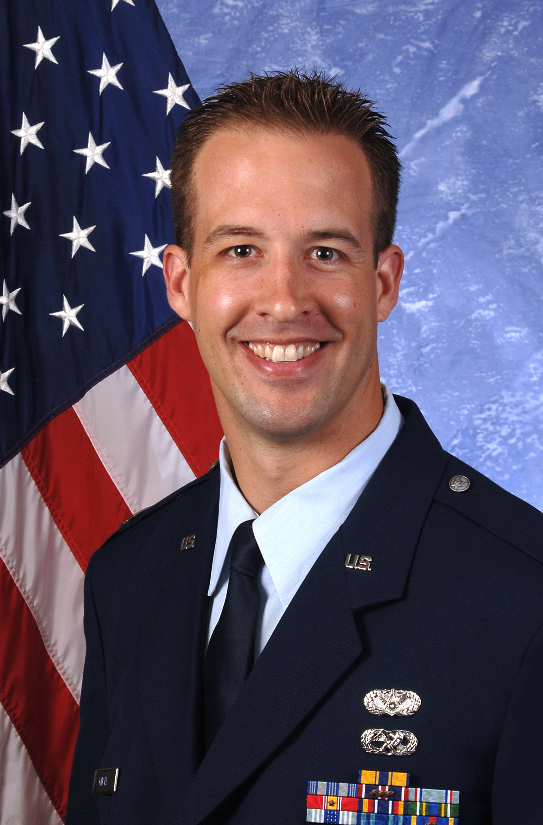
Lt Col Wayne C. Kinsel, USAFA 2001 – Currently serving as Commander, 322d Training Squadron, Joint Base San Antonio – Lackland, TX. He commands approximately 75 permanent party and 6,000 trainees per year, producing the Air Force’s newest Airmen. He is a career Air Force Civil Engineer (CE) previously assigned to numerous CE Squadrons both in CONUS and OCONUS, served as a staff officer at Air Force Material Command, the Air Force Civil Engineer Center, and Air Staff at the Pentagon. Wayne played all 4 years at USAFA and served as the Co-Captain January 2000 - May 2001. After graduation, he went on to play/coach rugby at various levels in North Dakota, South Korea, England, Ohio, Texas, and Alabama. He represented the Air Force select team as a player 2002-2009, winning Armed Forces Championships 2002, 2004-2009. Wayne was selected to the All Service team as the starting lock 2004 & 2009. He also helped capture the Paul-Milne Shield as a player against the Royal Australian Air Force in 2009 and as a coach in 2011. Wayne became an assistant coach for Air Force select team in 2010 and served as the Director and Head Coach 15s from 2011-2016. As the Head Coach, Wayne led the Air Force Select team to their 8th straight Armed Forces Championship in 2011.

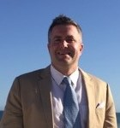
James “JPR” Lamar, ’95 Portfolio Manager at Gilder Gagnon Howe & Co., a New York City-based growth-oriented equity investment firm. Jimmy started playing rugby in the spring semester of his freshman year. By the fall semester of his sophomore year, he had earned a spot on the A-side and scored his first try at the University of Wyoming’s Jackalope Tournament. During the three and half years Jimmy played for the Zoomies, the team won three Western Collegiate Rugby Championships, was runner-up in the National Championships in 1993, third place in 1994, and runner-up in the National Championships in 1995. He was the co-captain of the team in 1995 and voted by his teammates as “Mr. Rugby” his senior season. While at the Air Force Academy, Jimmy was named to the Collegiate All-Western Team in 1993 and 1994; the Collegiate Combined Services Team in 1993, 1994, and 1995; and the Senior Combined Services Military Team in 1995. Following his cross-commission into the US Navy as a Naval Flight Officer, Jimmy played rugby for the All-Navy Select Team and the Senior Combined Services Team from 1995 to 2000. He is also the President and Founder of GloveLove Inc., a nonprofit organization that promotes compassion and leadership in young people through volunteerism and participation in youth sports.

Terms expiring in 2019

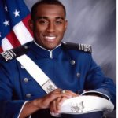
Captain D'Angelo "Ahdi" Mitchell '11, Buyer, Arcata Associates. Responsible for all buyer/procurement functions within assigned Lockheed Martin Integrated Product Team. Technical resource within the department in support of the master schedule for NASA's Orion MPCV Program. Recruited to USAFA Preparatory School for wrestling and soccer. Learned rugby as a Doolie and 3d class cadet. Helped with 2008 Combined Services team at National All-Stars Championship. Joined Olympic Weightlifting team as 2d class cadet and was invited to 2011 National Collegiate Championships as a Firstie; assistant strength and conditioning coach. Last assignment within the US Air Force was as Senior Instructor, Weapons and Tactics. Attending Harvard University for an MLA in Sustainability. Holds an MS in Aeronautics (Space Operations Management) from Embry-Riddle Aeronautical University, and a BS in Social Sciences and General Engineering from USAFA. Pursuing Nondestructive Testing certification. Guest speaker for USAFA's Management Department. Lives in Denver CO

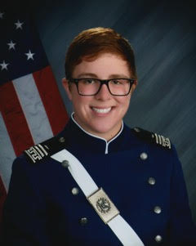
Lt Lydia Hill ’15. Lydia is an aircraft maintenance officer, currently stationed at RAF Mildenhall. While at the Academy, Lydia played rugby for 3 years, she was captain of the team her junior and senior year, leading the team to two regionals appearances in 15s, a 3rd place finish at 7s CRCs, a 3rd place finish at the 7s ARCA championship, and a 9th place finish at the 7s Collegiate Rugby Championships. She was selected as a USA 2nd Team All American and USA Rugby Academic Honor Roll two years in a row. While a senior on the team, Lydia helped plan the first ever Piper Cup. Currently, Lydia is a member of the Diversity/Inclusion Board at RAF Mildenhall.

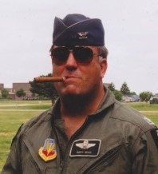
Gary Read, ’74. Col (Ret) Gary served from 1974-1998 as a Fighter Pilot, Fighter Weapons School Instructor, Operations Officer, Squadron Commander, Logistics Group Commander, and Operations Group Commander in the Active Air Force and as a full-time officer in the Iowa and Kansas Air National Guard. After retirement he joined Cessna Aircraft Company in Wichita, KS and flew as a Senior Demonstration Pilot for 15 years. During this time he flew all Cessna Citation Jet models around the world helping the sales process. Gary did not play after graduation, but since retiring from flying is following the team through e-mail updates\

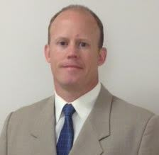
Colonel Brian Schafer, ’95. Currently a student at the National War College, Ft McNair, Washington DC, Brian has served on the Joint Staff, as CO and XO for a joint pilot training program (NAS Whiting Field), as well as a DO in Afghanistan directing the largest MC-12W unit in the Air Force. Starting out as an acquisition officer, then transitioning through pilot training to operational F-15C squadrons, he has over 3000 flying hours in the F-15C, T-6B, MC-12W, and has had several roles as IP, MSN CC, and Flight Examiner. He played all 4 years at the Academy as #8/Flanker, and post-graduation with Santa Barbara, San Luis Obispo, Okinawa, Panama City, and Okaloosa Men’s teams, representing the Air Force with selections to the Combined Services Seniors/Juniors and USAF Men’s team. Brian is also a civilian flight instructor (ATP, CFII) and he and his wife and two sons live in Falls Church, VA.

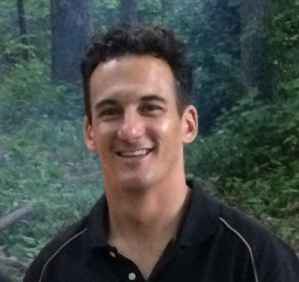
Colonel Jeff Geraghty, ’97 Jeff is Commander of the 645th Aeronautical Systems Group (aka "Big Safari"), at Wright Patterson AFB, OH. Known to his zoomie teammates as "Spicoli," Jeff played high school rugby in Colorado and three years on the A-side at AFA as winger, center, fullback, and flyhalf. He was elected captain in his senior year and was selected to the Combined Services U-23 team. Jeff and his wife, Nora, and their three children live in Bellbrook, Ohio.

Terms expiring in Sept 2020

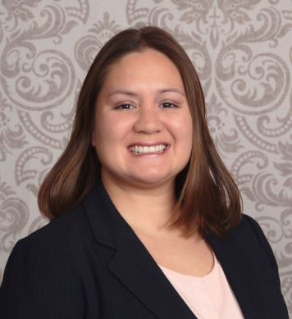
Maj Nikki Foster, ‘03 is currently at GE Aviation in the Junior Officer Leadership Program in Cincinnati, OH. She responsible for eliminating cost on the GP7200 engine overhauls for the Airbus A380. She is also a reservist as a Kentucky Academy Liaison Officer (ALO). She was previously on active duty for 12+ years as a KC-10 IP Commander with 3000 flying hours (1400 combat). She was a 4 year starter at wing/fullback for teams that won the West Regional Championship 4 times and two times National Champions. She was selected as 2nd team All American at wing in 2003. She went on to assist the AFA women’s team as assistant coach and OIC 2009-2011. She and her husband Robert have a 6 year old son, who will someday know her rugby nickname is Spaz/Spazzie.

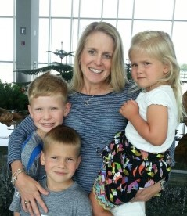
Col Melissa K. Phillips, ’96. Previously flew the C-141, C-17 as an Airdrop A/C Commander, and T-37 IP at Sheppard. She is currently in the AF Reserve assigned to the Air Force Academy supporting BCT each summer where she will be the BCT Deputy Group Commander in 2015. Melissa played rugby all 4 years at USAFA, playing center positions and later scrumhalf. Factoid: both Melissa and her father (Dave Baumann, 1971) played under Coach Alan Osur. She was a member on the 1994 National Championship team and served as the OIC from 2005 - 2009. She has three children of her own, ages 9, 7 and almost 5.

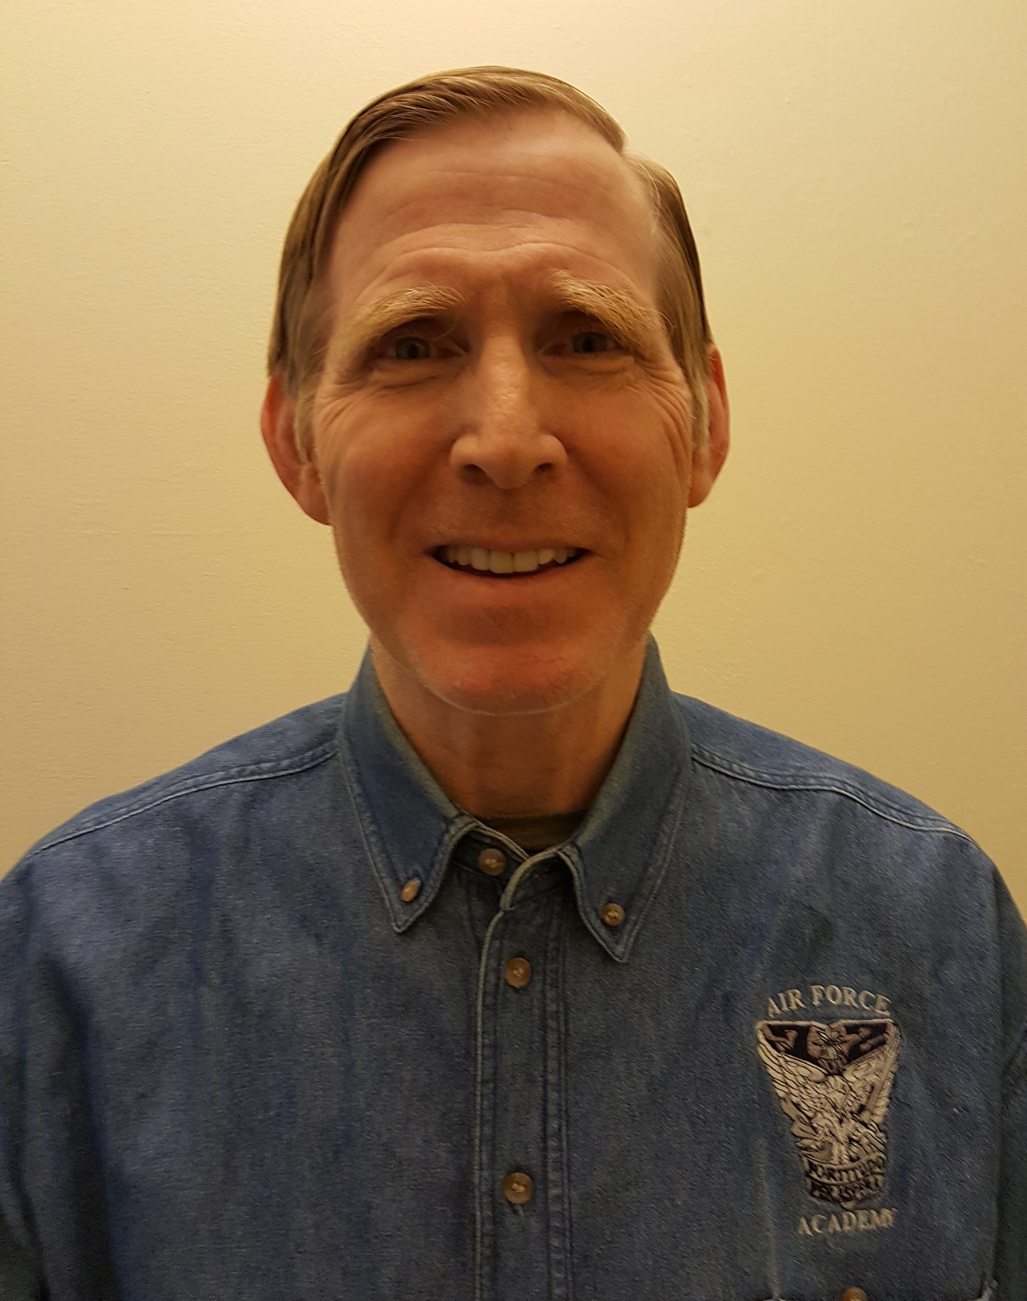
Jim Woessner, ’72. Lt Col (Ret). Currently retired from a family business started by my grandfather in 1936, Dayton Supply and Tool, that served the manufacturing sector in the southwest region of Ohio providing customers with the latest cutting tool technology and processes. Currently, through a program known as TechFest, is intricately involved in motivating school age children toward careers in Science, Technology, Engineering, and Mathematics (STEM) to fill the vacancies in manufacturing corporations. Served in the Air Force as a Meteorological Officer with assignments at Penn State for a BS in Atmospheric Sciences, Fairchild AFB supporting SAC, remote to an Army post in Korea within artillery range of the northern barbarians, grad school at University of Washington, the AF’s Civil Engineering Center at Tyndle AFB, Offutt AFB at Global Weather Center, Clark AB in the Philippines as the commander of a weather detachment escaping the eruption of Mt Pinatubo by one day, and to my retirement assignment at the Pentagon. While at Penn State, had a great time on the PSU Rugby club playing against all the big Eastern city teams and carried on at Fairchild with the local rugby club.

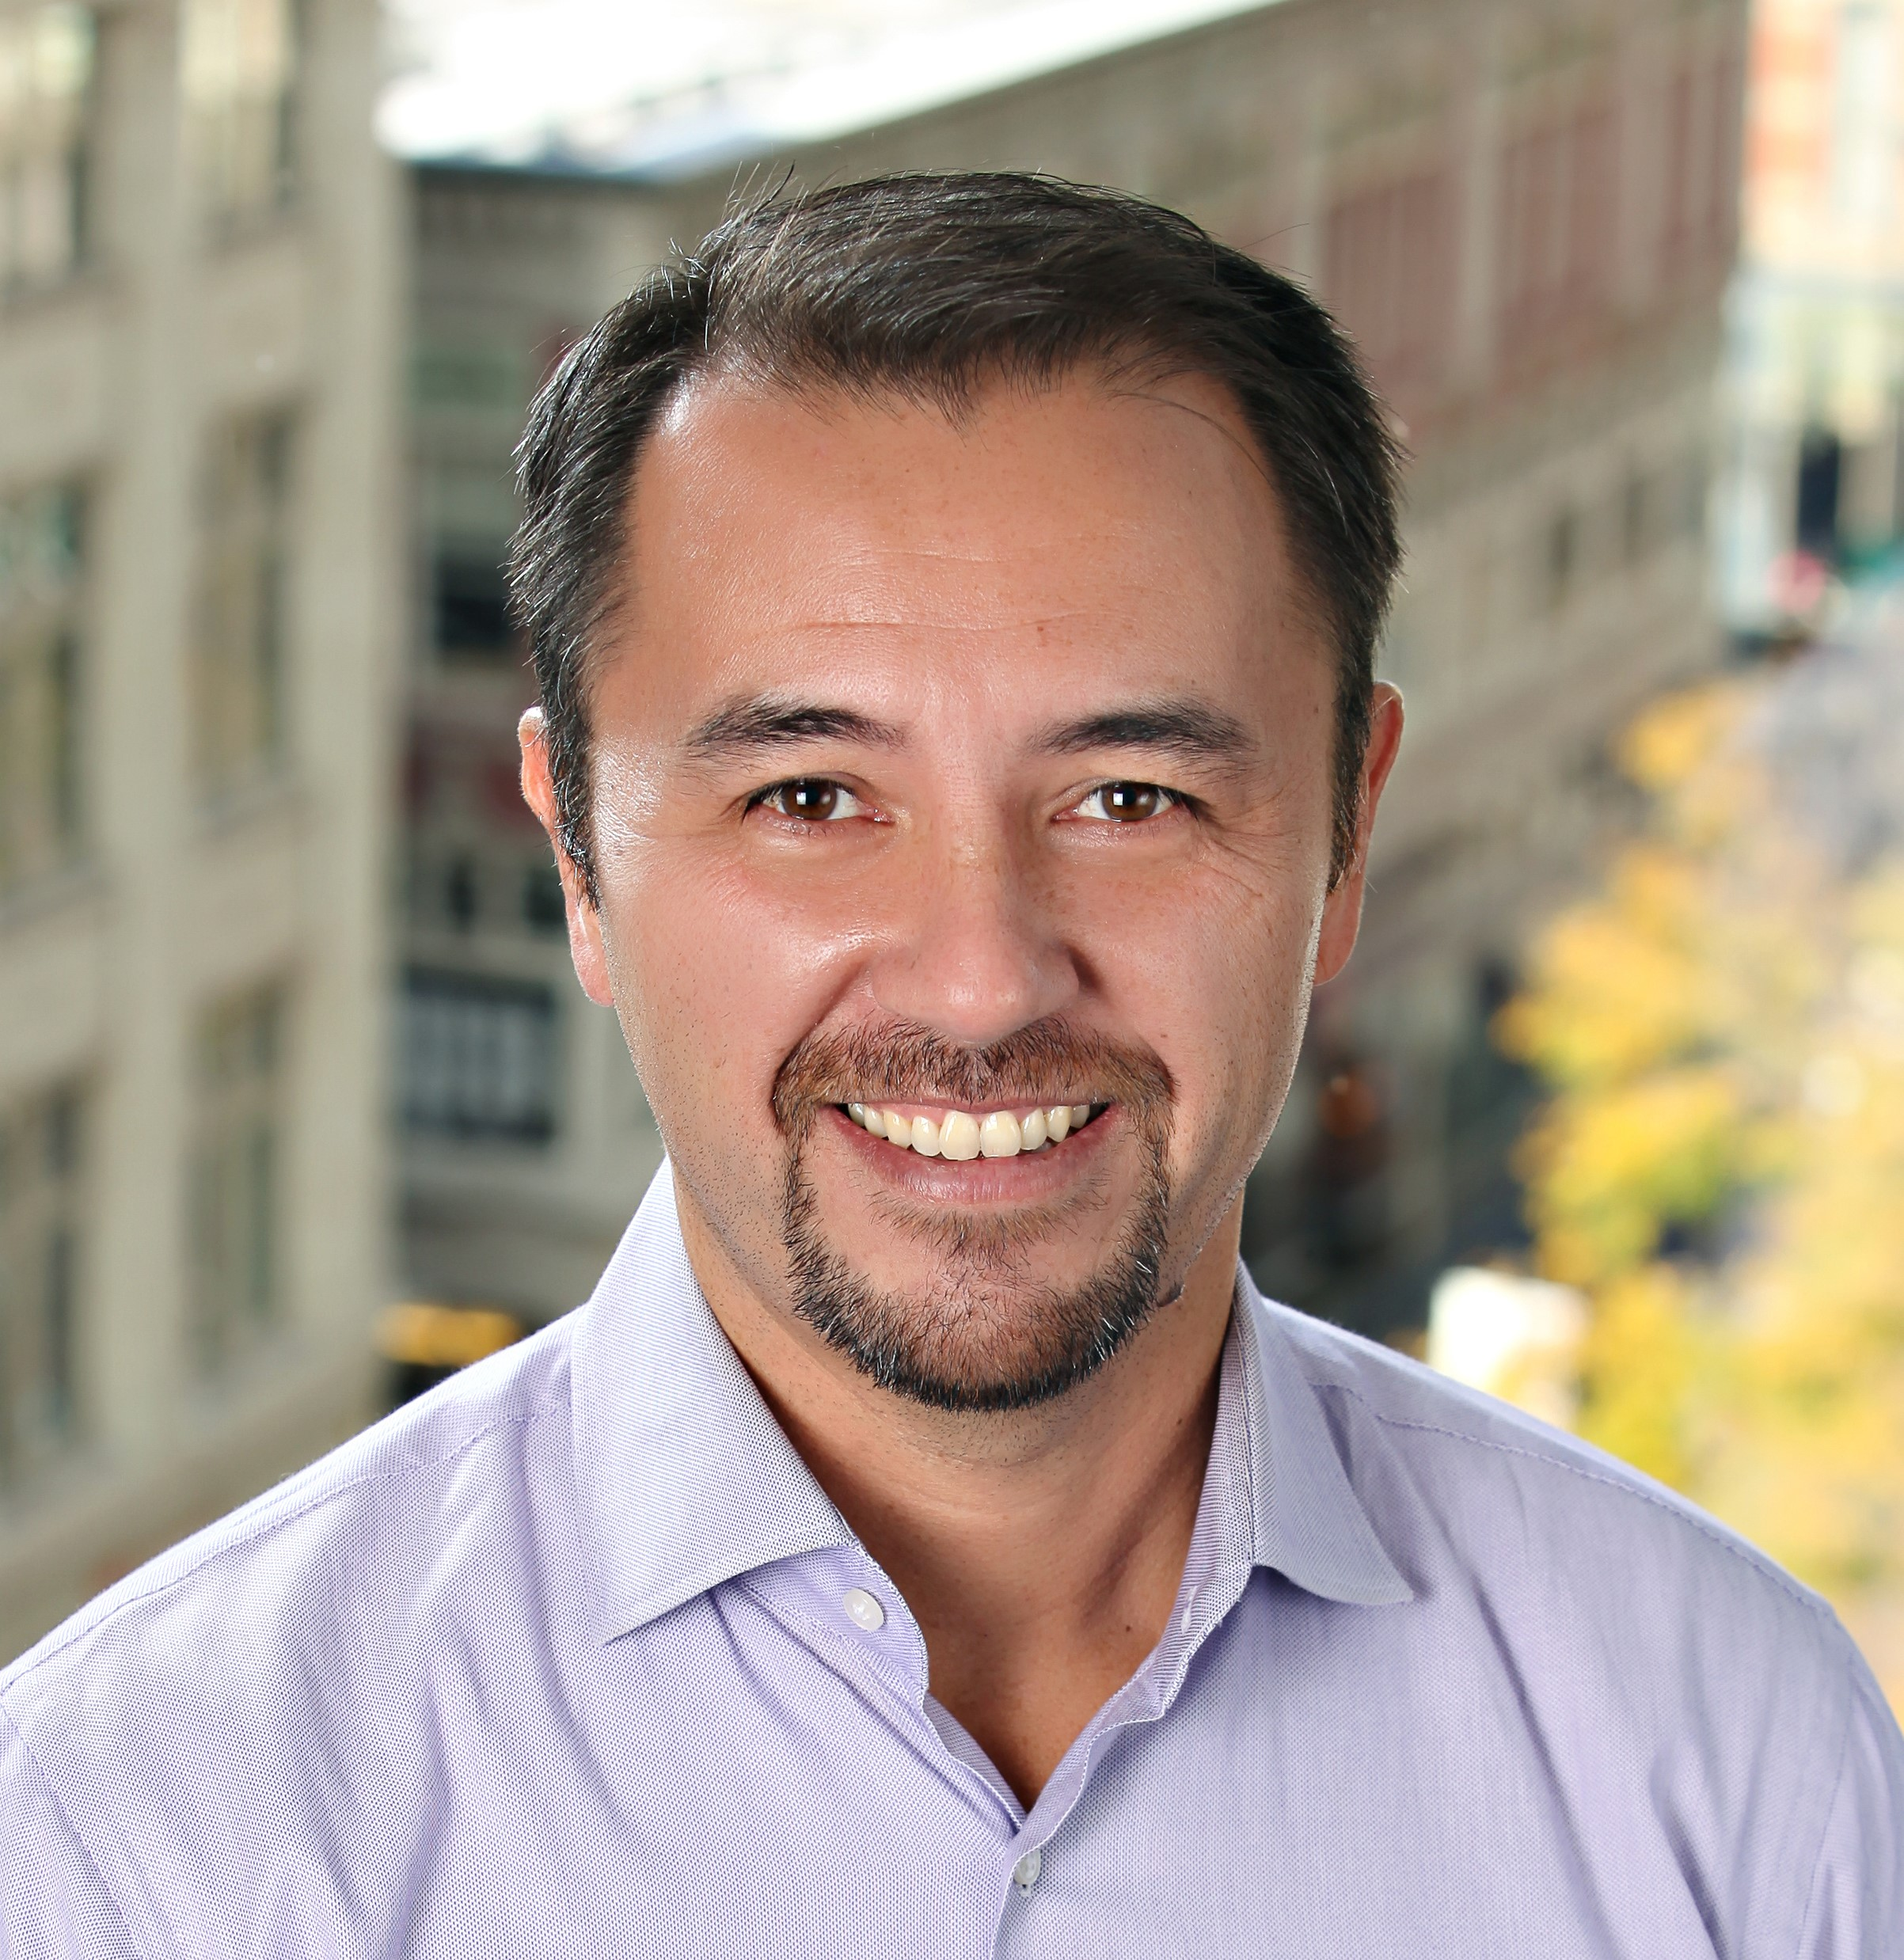
Martin Payne, ’92. Martin is most recently Chief Operating Officer of GutCheck, a services partner to Fortune 2000 companies such as P&G, Nestle, and Google providing rapid consumer insights that optimize new product innovation and marketing communications. He has 20+ years of leadership experience, 5 in the Air Force and nearly 20 in the civilian sector in technology-based businesses including Dell, Oracle, and Global Healthcare Exchange. As flanker, he was on the 1991 team that went to the ERRFU championship and the 1992 team that placed 3rd nationally finishing that season as the scrum MVP. He went on to play for Harvard Business School after USAFA.

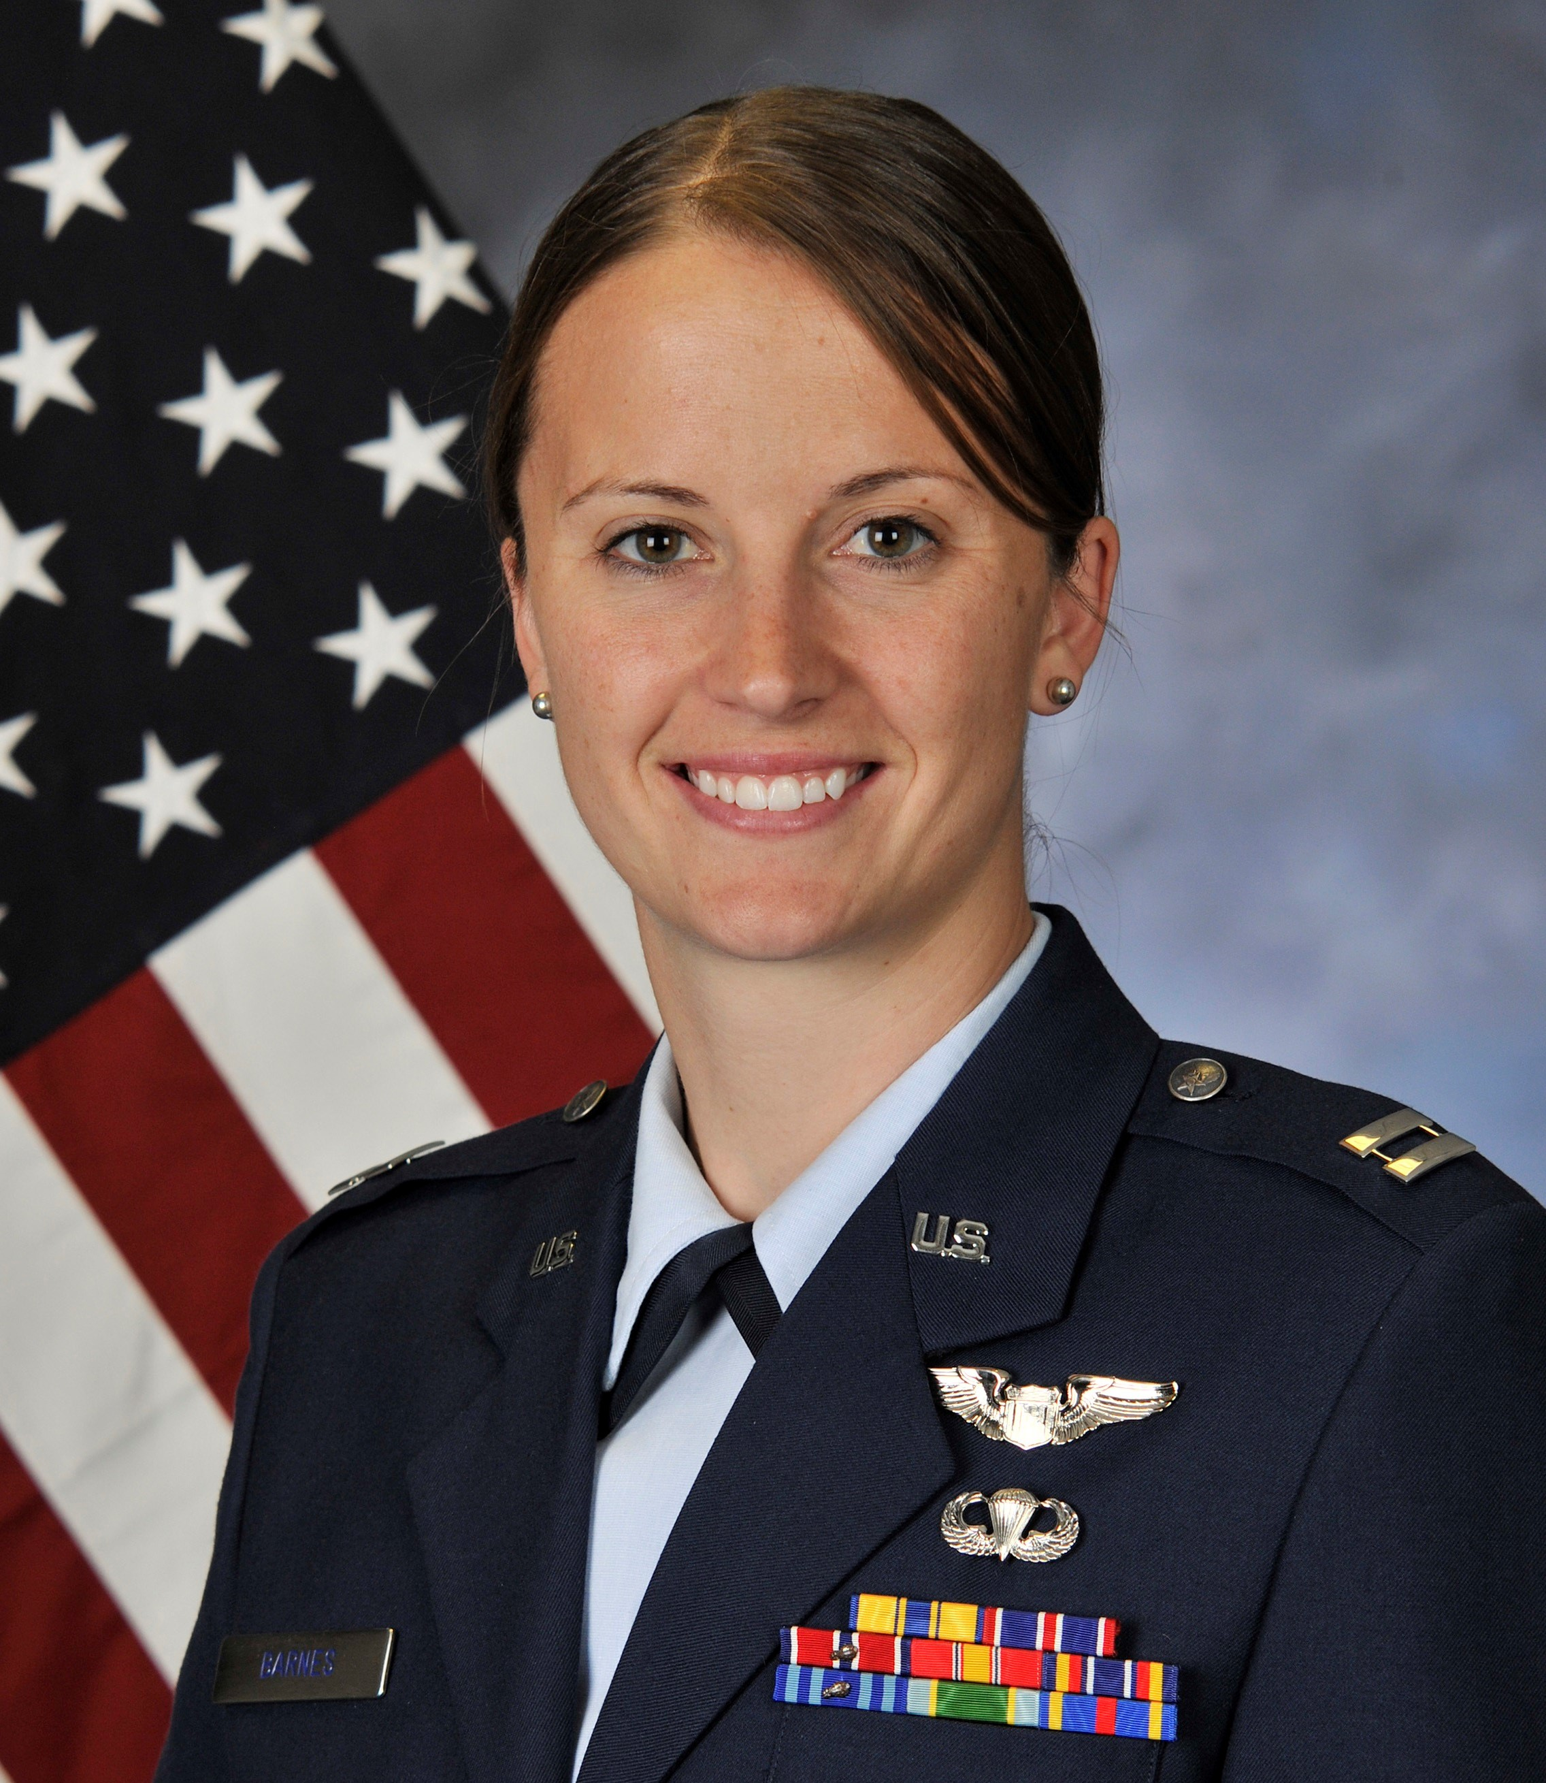
Captain Ashly Barnes, '08, is currently a CV-22B pilot and Flight Commander stationed at RAF Mildenhall and was previously an Evaluator Pilot on the UH-1N "Huey". She played rugby all four years at USAFA and was co-captain her senior year, playing predominantly as fly-half but in other back-line positions as well. Ashly was selected to the Eastern Rockies Rugby Football Union Select Side Team during her junior and senior year, and served as that team's co-captain in 2008. In 2015, she co-coached the Albuquerque Pumas girls high school rugby team, who placed 3rd at the state tournament.

CLUB OFFICERS

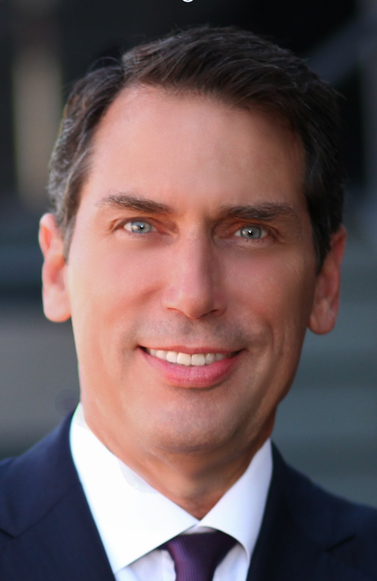
President
Nathan “Nate” Rosenberg, ‘74. Founding partner of Insigniam, an international management consulting firm. Nate was the first member of the class of ’74 to step onto the pitch in the fall of his first year at the Academy. Sliding from wing three-quarter to second row to number 8 to blind side wing forward in his 4 years, he was slow but had hands of stone. He cross commissioned to the Navy, flew search-and-rescue, served as the SecDef’s executive support officer, and was national defense advisor to the Majority Leader of the U.S. Senate. He played for NAS Pensacola RFC, Miami RFC and the Florida Touring Side. Nate is a board officer both for the Boy Scouts of America and Educate Girls Globally, is a trustee of the Committee for Economic Development and serves on the board of the Orange County Council of the Boys Scouts of America. Every year for the last 21 years, he has been a guest lecturer for the AFA Department of Management.

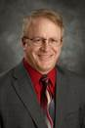
Immediate Past President
Mike Cartney, Colonel (ret) ‘81, President, Lake Area Technical Institute, Watertown, SD. Thirty year intelligence veteran decorated for duty during Desert Storm, Bosnia, Kosovo, Operation Enduring Freedom, Operation Iraqi Freedom, Global War on Terrorism and War on Drugs. Intelligence role included work with Drug Enforcement Agency, US Marshall Service, FBI, and various intelligence agencies. Rugby career included: A-side hooker for AFA 80-81, A-side hooker for USNA (79 -- exchange Cadet), CIC 81 team, Member of ERFFU Referee, Head Coach of USAFA 1993 National Runner-up team, Coach of Under 21Military All-stars. Founding member of ZRFC Alumni and Parents organization.

Treasurer

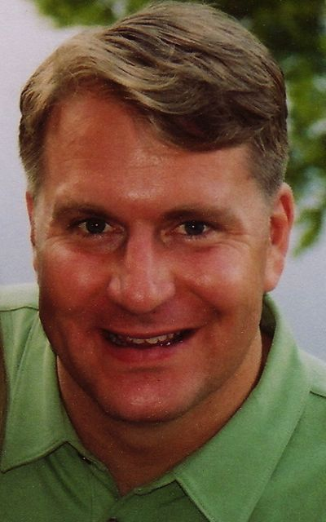
Chuck Thompson Lt Colonel (Ret) ’94. Currently, Chuck is a B-737 Captain with Southwest Airlines based in Denver. Chuck served 10.5 years active duty as a C-21 Instructor Pilot, C-130 Aircraft Commander, and T-1A Instructor Pilot serving in Bosnia, Kosovo, Operation Northern Watch, and Plan Colombia. He served 10 years in the AF Reserves as an Admissions Liaison Officer where he was the Liaison Office Director for Southern Colorado as well as the National Training Phase II Director. A four-year member of the AFA rugby team, he played as a fullback, winger, and inside center. Post graduation, Chuck played with the Colorado Springs Rugby Club and with the RAF Ramstein team while stationed in Germany. He is currently the Treasurer of the Lady Kadet Lacrosse Association for Air Academy HS. Chuck is married to his wife Kit, and has three children: Shelby, Audrey, and Zachary. Chuck lives in Colorado Springs, Colorado.
Ahdi Mitchel (assistant)

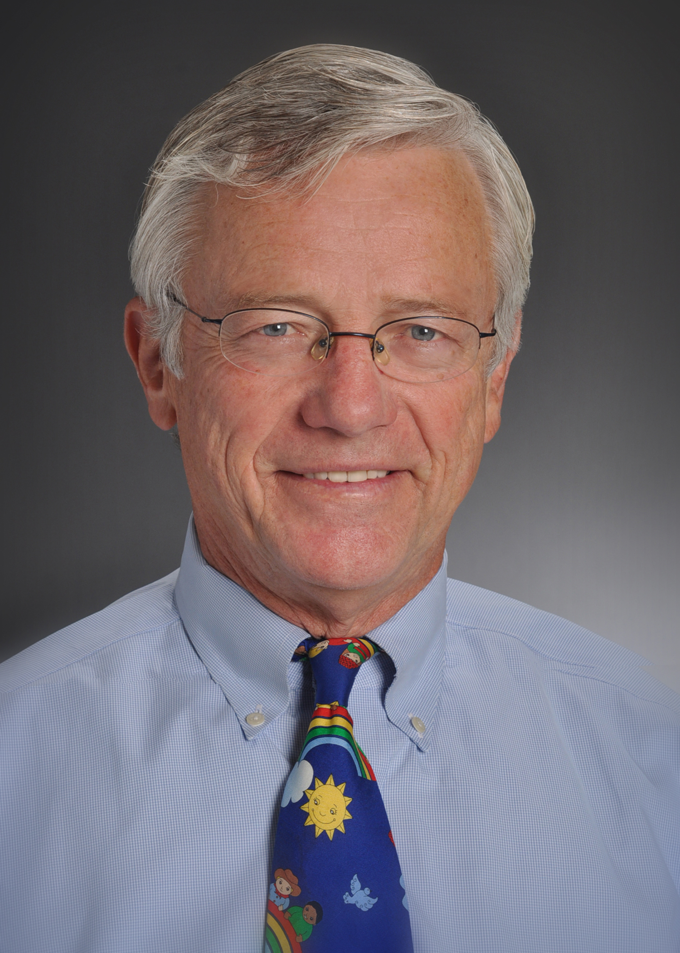
Secretary
Harry Laws, MD, ’69, Colonel (ret), Pediatrician and past Health IT consultant, Wisconsin. Twenty Five years active duty as a physician, hospital commander and administrator. Continuously involved in rugby since being a part of the first AFA intercollegiate team, both as player, captain, club administrator, coach, referee, referee trainer and evaluator across the US, Europe and Asia. Currently is a local and territorial level referee evaluator and International Rugby Board referee Trainer. Was a founding member of the Indiana Youth Rugby Foundation and served on the board for 16 years. Founding member of the AFA AOG Rugby Affinity Group.

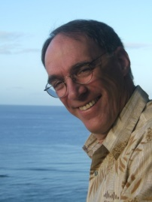
Colorado Springs Contingent Leader
Bill Diffley 73 LtCol (ret). Bill served a long career as a C-141 pilot, 6 years active and 15 years reserve. Along the way he earned an MBA and from 1980 to the present flies for PSA, US Airways (soon to be American Airlines), currently an A330 Captain. Bill never played after the Academy, but is an avid spectator of our sport. He has a decade of experience in PTA, as treasurer, President and Board member.

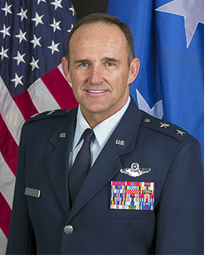
Booster Club Liaison

MG Tru Eyre, '79. (http://en.wikipedia.org/wiki/Trulan_A._Eyre) Major General Trulan A. Eyre is Air National Guard Assistant to the Commander, Continental United States North American Aerospace Defense Command Region and 1st Air Force (Air Forces Northern), Tyndall Air Force Base, Florida. He has 32+ years of fighter and trainer experience, with a total of over 4300 military hours, of which over 100 are combat hours, and is a Captain with Delta Air Lines. As scrum half, was the co-captain in his junior and senior years, and was part of the team that won the very first "collegiate championships" held in 1978, which was the precursor to the "national championship" tournament that started in 1980. Went on to play for several teams primarily overseas during Active Duty career. Serves as a member of the Aurora, CO Chamber of Commerce Board, the Aurora, CO Defense Council, and a board member of the CO National Guard Education Scholarship Fund Foundation.

